Brazilian future land-use dynamics in diverse biophysical and socioeconomic scenarios

Geanderson Ambrósio1,2, Jan Philipp Dietrich1, Denis Cunha2, Miodrag Stevanovic1, Alexander Popp1, Ewerton Araujo1,3, Hermann Lotze-Campen1,4

1 Potsdam Institute for Climate Impact Research (PIK), Potsdam, Germany.

2 Universidade Federal de Viçosa, Departamento de Economia Rural (DER), Viçosa - MG.

3 Universidade Federal de Pernambuco, Programa de Pós-Graduação em Economia (PIMES), Recife - PE.

4 Humboldt-Universität zu Berlin, Department of Agricultural Economics, Berlin, Germany.

**Área ANPEC:** Área 11 - Economia Agrícola e do Meio Ambiente. **JEL Classification:** Q10, Q50

Abstract

The prior knowledge on how the land-use change (LUC) should evolve over time depends on the relationship between agricultural production and forest conservation, on socioeconomic and biophysical features, and it has geographical specific dynamics. However, projections of Brazilian land use over time accounting for the above-mentioned features are still largely unexplored. The present research uses the global land-use model MAgPIE-Brazil to assess Brazilian land-use dynamics by projecting and evaluating 14 potential Brazilian LUC pathways over this century. Results suggest that Brazilian land use can evolve in diverse pathways depending on the socioeconomic and biophysical assumptions. Cropland may expand 75% or decrease 30% in 2100 compared to 2020, depending on the scenarios. Cropland continues to expand until 2040, especially in the South and Northeast regions. Pasture area can remain practically stable or reduce by more than 50% by 2100 compared to 2020 depending on the scenarios. The pasture area has already reached its peak and important decrease in the coming decades is expected for most scenarios. Deforestation and depletion of natural land reduce in the next decades and fade out in 2040 in most of the scenarios. This dynamic is due to the abandonment of pasturelands and can be due to policies to reduce deforestation. The diverse plausible pathways suggest that Brazil may still have time to drive its LUC according to its interests.

Keywords: land use, deforestation, Brazil, MAgPIE, MAgPIE-Brazil

Resumo

O conhecimento prévio sobre como a mudança no uso da terra deve evoluir ao longo do tempo depende da relação entre produção agrícola e conservação de florestas, das características socioeconômicas e biofísicas, e possui dinâmica geográfica específica. No entanto, projeções do uso da terra brasileira ao longo do tempo, considerando as características acima mencionadas, ainda são pouco exploradas. A presente pesquisa usa o modelo global de uso da terra MAgPIE-Brazil para avaliar a dinâmica do uso da terra no Brasil, projetando e avaliando 14 possíveis trajetórias de mudança de uso do solo ao longo deste século. Os resultados sugerem que o uso da terra no Brasil pode evoluir de diversas maneiras, dependendo das premissas socioeconômicas e biofísicas. A área agrícola pode expandir 75% ou diminuir 30% em 2100 em comparação com 2020, dependendo dos cenários. A área agrícola continua expandindo até 2040, especialmente nas regiões Sul e Nordeste. A área de pastagem pode se manter praticamente estável ou reduzir em mais de 50% em 2100 em comparação a 2020, dependendo dos cenários. A área de pastagem já alcançou seu pico um decréscimo importante nas próximas décadas é esperado para a maioria dos cenários. O desmatamento reduz nas próximas décadas e zera em 2040 na maioria dos cenários. Essa dinâmica pode se dever ao abandono das pastagens e as políticas de controle do desmatamento. Os diversos caminhos plausíveis sugerem que o Brasil ainda pode ter tempo para conduzir seu uso da terra de acordo com seus interesses.

Palavras chave: uso da terra, desmatamento, Brasil, MAgPIE, MAgPIE-Brazil

Brazilian future land-use dynamics in diverse biophysical and socioeconomic scenarios

1. **INTRODUCTION**

Agricultural land has been expanding over other natural land since agriculture has suppressed hunt as a way of living (KAREIVA *et al*., 2007). More recently, the growing population with higher food demands required even more agricultural production, which has been met by both extensification (FOLEY, 2005) and intensification (RAY *et al*., 2013). In the 1980s and 1990s, tropical forests were the main sources of new agricultural land (GIBBS *et al*., 2010), especially in developing countries. Brazil faced such agriculture expansion and has now a large-scale agricultural system characterized by historical massive governmental intervention (CHADDAD *et al*., 2006) and satisfactory environmental conditions (EMBRAPA, 2018). From the end of 1990s, the increasing international demand and agricultural yields, as well as the depreciation of Brazilian Real, enabled the country to become one of the global major crop and livestock products exporters (EMBRAPA, 2018; MUELLER; MUELLER, 2016) and a technological leader in soybean production (EMBRAPA, 2018). Nowadays, the country is one of the top five producers of coffee, soybean, orange, beef, and corn (ANDERSSON; AXELSSON, 2016).

The success of Brazilian agriculture has been associated with widespread ecosystems depletion, especially the Cerrado, Amazon rainforest (MARTINELLI *et al*., 2010) and Atlantic Forest (RIBEIRO *et al*., 2009). The estimated remaining Atlantic Forest is between 11.4% and 16% of its original land (RIBEIRO *et al*., 2009), half of the Cerrado biome has already been replaced by cropland or pastureland (CARVALHO; DE MARCO; FERREIRA, 2009) and in Amazon biome 82.8% remains as forestland and 11.6% as agricultural land (MAPBIOMAS, 2019). Despite such depletion of natural land, the related activities of forests are strategic for providing ecosystem services and goods (STRAND *et al*., 2018), including driving local climate by modulating energy and water fluxes (ALKAMA; CESCATTI, 2016).

In the recent decades, environmental importance of forests and its historical dichotomous association with agricultural expansion has been taken into account in the agricultural planning (BRASIL, 2009b, a, 2010, 2012, 2018; BRAZIL, 2015; MARTINELLI; FILOSO, 2009). National environmental policies can drive national land-use change but it also affects international land dynamics due to interconnected global markets (MEYFROIDT *et al*., 2013). In the same way, other countries’ policies can also affect Brazilian land-use dynamics. In this sense, studies accounting for global dynamics with focus on Brazil’s specificities are required, despite still not much explored. The partial equilibrium economic model GLOBIOM-Brazil was the first global model to explicitly focus on Brazil (CAMARA *et al*., 2015), projecting Brazilian land from 2000 to 2050 in ten year time steps. This model has detailed representation of Brazilian livestock and cropland allocation based on national statistics, some features of the Forest Code, the Soy and Cattle Moratorium and other refinements (SOTERRONI et al., 2018a). However, GLOBIOM-Brazil still lacks on representing Brazilian land use under more diverse socioeconomic and biophysical scenarios. In the present research, we contribute to the diversity of global approaches by using MAgPIE-Brazil to address the following question:

1. How would Brazilian LUC dynamics evolve over this century under diverse biophysical and socioeconomic pathways?

Analyzing land-use projections beyond 2050 and in diverse scenarios will contribute to build knowledge for long-term Brazilian land-use policy.

1. **METHODS**
   1. **MAgPIE-Brazil**

The complex relations between LUC and global environmental change issues at the country scale requires methods able to account for such complexity, both from the biophysical and from socioeconomic perspectives. The Brazilian regionalized version of the Model of Agricultural Production and Its Impact on the Environment (MAgPIE-Brazil) (DIETRICH *et al*., 2019) is a global land-system model that meets this criteria by explicitly focusing in Brazil and its commercial partners. MAgPIE-Brazil is a partial equilibrium global model that minimizes a goal cost function through recursive dynamic optimization under the constraint of fulfilling an exogenous demand for food and other specifics restrictions, such as deforestation policies.

* 1. **Input data and Clusterization**

MAgPIE-Brazil uses two diverse levels of input data: grid (0.5 by 0.5 degree) and regional (country and region scale). Grid level data are the yields of 19 crops[1] and pasture, both irrigated and rainfed, Carbon stocks in soil, litter, and vegetation, water availability and water demand, and travel time to reach the closest city with 50.000 inhabitants. The global vegetation and hydrology model Lund-Potsdam-Jena managed Land (LPJmL) (BONDEAU *et al*., 2007) provide the yields, carbon and water data to be used by MAgPIE. For providing it, LPJmL uses the climate model IPSL-CM5 Earth System Model in all the Representative Concentration Pathways (RCPs) (VAN VUUREN *et al*., 2011). Travel time is taken from Nelson (2008) and the relative transport costs for each product are calibrated using total agricultural transport costs taken from the GTAP 7 database (NARAYANAN; WALMSLEY, 2008).

Although grid level input data is available at 0.5°, it is necessary to aggregate the grid cells into clusters before running MAgPIE-Brazil due to computational and feasibility requirements. The clusterization process (DIETRICH; POPP; LOTZE-CAMPEN, 2013) aggregates similar cells regarding yields, time travel, water availability and the MAgPIE-Brazil regional setup (discussed in the next paragraph). MAgPIE-Brazil uses 500 clusters, mainly focusing in Brazil and its commercial partners. By focusing in Brazil, it loses information in other areas, but this decision is in consonance with the research question that is designed from the Brazilian perspective. Figure 1 presents the cluster distribution in MAgPIE-Brazil.

Region level data includes population, income, food demand, diet composition, and others. Population and income are defined by the Socioeconomic Shared Pathways (SSPs) (O’NEILL *et al*., 2017; RIAHI *et al*., 2017) and are exogenous to the model. MAgPIE-Brazil uses 6 regions: United States (USA), China (CHA) and Europe (EUR) due to its importance for commerce, Rest of Latin America (LAM) due to its implication for deforestation, Brazil (BRA), and Rest of the World (ROW) which aggregates the other countries. The main disadvantage of having one big region as ROW is that this area is trade-free, which does not fit the reality. However, from the Brazilian perspective, the dynamics in ROW are less relevant than in the other regions of MAgPIE-Brazil. Figure 1 presents the regional setup in MAgPIE-Brazil.

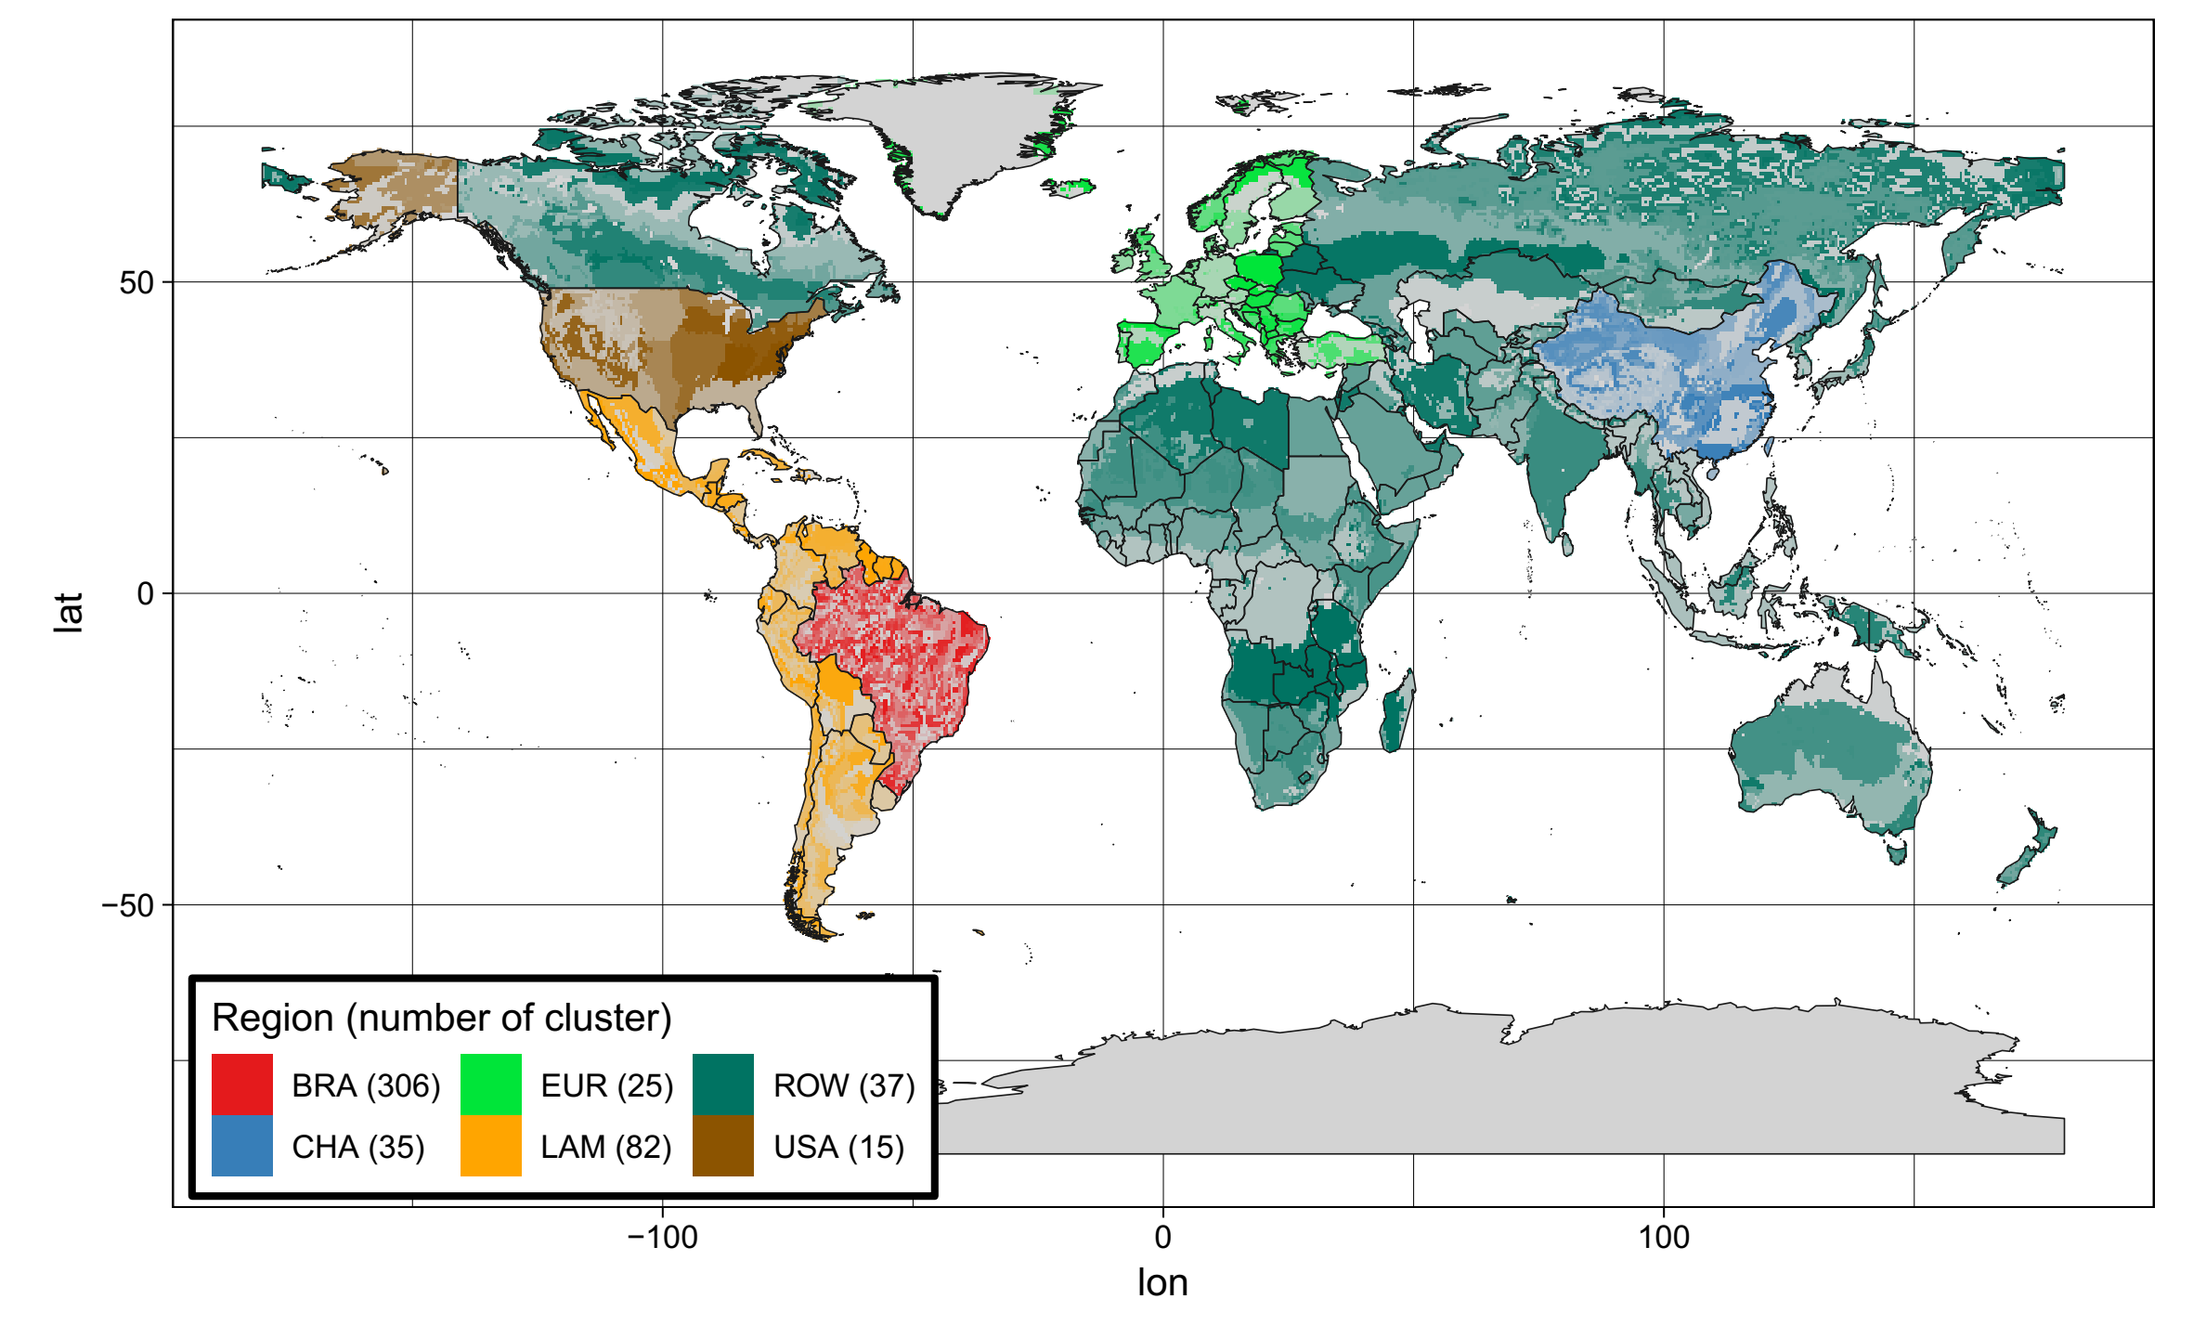

Figure 1. MAgPIE-Brazil regions and cluster setup: 6 regions and 500 clusters (DIETRICH *et al*., 2019).

* 1. **The cost minimization function**

MAgPIE-Brazil minimizes a goal cost function under the constraint of fulfilling an exogenous demand for food and other specifics restrictions. For doing so, diverse modules calculate their costs and deliver their calculations to the *costs* module. The *costs* module aggregates the global costs of production (*vm_cost_glo*), which is the sum of each region’s (*i*) production cost (*v11_cost_reg*):

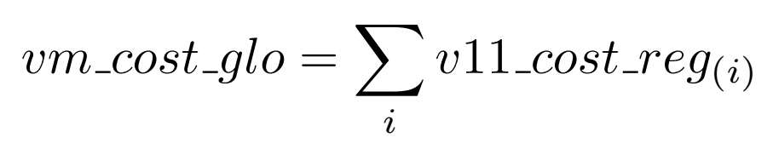

Region’s production cost is represented by the sum of the cost of different production activities. These costs account for irrigation expansion, afforestation, land conversion, processing, factors, punishment costs for overrated cropland difference, regional trade costs, transportation, costs for emission rights for pollutants and GHGs, costs of technical mitigation of GHG emissions, inorganic fertilizers, mineral fertilizers, revenues (or a negative cost) for Carbon captured by afforestation and costs for technological change. After module *costs* aggregate all production costs, data is delivered to the module *optimization* in order to achieve the best feasible solution for the cost minimization problem for each time step (*t*). The cost minimization occurs under diverse constraints that can be placed at any geographical level and time step, according to the representation of a real-world dynamic.

* 1. **Land-use change and deforestation**

MAgPIE-Brazil has seven diverse land types: *urban*, *cropland*, *pastureland*, *forestry*, *primary forest*, *secondary* *forest,* and *other land*. *Urban* is the only static land type with the spatial distribution of 1995 and the others are dynamic over time. *Cropland* is the area for cultivating the 19 different crops, including crops for food, for feed and bioenergy crops. *Pastureland* is the area for pasture, which is one of the inputs for livestock products. Agricultural land accounts for *pastureland* plus *cropland*. *Forestry* is defined as areas of afforestation and reforestation due to afforestation and based on FAO Forest Resources Assessments (2019) and is also referred as managed forest. *Primary forest* is untouched forest and *secondary forest* has been modified by human activities somehow. Full-grown *primary forest* and full-grown *secondary forest* have the same carbon content, but *secondary forest* has lower carbon density on its age-classes. Data on primary and secondary forests are based on Land-Use Harmonization 2 (LUH2) (2019) and internally calibrated to match FAO Forest dataset. Forestland accounts for the sum of *forestry*, *primary forest,* and *secondary forest*. *Other land* is all natural land that is not forestland neither agricultural land neither *urban*. It includes deserts, mountains, and savannahs, and abandoned agricultural land. Natural land accounts for the sum of forestland and *other land*.

Before the optimization, MAgPIE-Brazil calibrates the yields from LPJmL in order to make *cropland* and *pastureland*, in each region, to meet the historical area from FAO for the year 1995. When moving from one time step to the next, the model starts the optimization to minimize the cost function taking into account the optimal solution from the previous time step. The model endogenously decides for the agricultural land to reduce, expand, intensify or maintain it as it is, at each cluster, for each product, at each time step, according to the demand for food, feed, bioenergy, and materials. Land-use change across land types occurs when the share of the diverse land types change over time in a specific area (cluster, region, or any area defined). Deforestation is a specific kind of land-use change that occurs when the share of *forestry*, *primary forest* or *secondary* *forest* decrease over time in a specific area. There are diverse drivers determining land-use change like food and feed demand, yields, land conversion costs, technological change costs, water availability, interest rate, trade, biophysical suitability for crops and deforestation policies. Forestland protection is a constraint to the model implemented at the grid level and aggregated to the cluster level through Clusterization. MAgPIE-Brazil fulfills the constraints that deforestation in Legal Amazon in 2020 must be 80% below deforestation in 2005 (Policy starts in 2005) (BRASIL, 2018b), deforestation in Cerrado in 2020 must be 40% below deforestation in 2010 (policy starts in 2010)[2] (BRASIL, 2016) and deforestation in Atlantic forest is not allowed (policy starts in 1995) due to evidence that it is recovering in the last year (MOLIN *et al*., 2017).

One important feature of MAgPIE-Brazil is that technological change do not differentiate between crops, i.e. investments made for the crop will increase the productivity of all crops in the region. Investments in technological change to increase crop yields occur as a response to increasing demand and increasing land competition. Investments in technological change to increase pasture yields, however, only occur as a response from demand dynamics. It relates to an exogenous pasture management factor based on a demand-side proxy for a growth rate of cattle stocks. For example, if the growth of Brazilian cattle stock increases due to livestock relocation from other countries, then the pasture yield increase as well. One limitation of this approach is that the exogenous implementation cannot capture feedbacks between land scarcity and efforts to improve pasture management. MAgPIE-Brazil is only able to intensify pasture production due to increased pasture demand, but not due to increased land competition.

* 1. **Biophysical and Socioeconomic scenario-based analysis**

The RCPs and SSPs are implemented in MAgPIE-Brazil in order to account for a broader range of plausible biophysical and socioeconomic pathways. In the present research, three RCPs are considered: RCP2.6, consistent with achieving the 2ºC warming target; RCP4.5 and RCP6.0, both related to stabilization of radiative forcing without overshoot (VAN VUUREN *et al*., 2011). On the socioeconomic side, the SSPs are implemented in order to account for challenges for mitigation and adaptation. According to O’neill *et al.* (2017), the SSPs are characterized as follows: SSP1 has low challenges for mitigation and for adaptation, it depicts a sustainable development world and a break with recent history. The SSP2 has business as usual scenario; it represents a continuation of the trends observed in the last century. The SSP3 has high challenges for mitigation and adaptation; it reflects international fragmentation and a world characterized by regional rivalry. The SSP4 has low challenges for mitigation and high for adaptation, as it is characterized by inequality, in which developing countries are still pursuing development. The SSP5 has high challenges for mitigation and low for adaptation, it represents accelerated globalization and rapid development of developing countries and high dependency on energy (which can come from fossil fuels or from bioenergy, depending on the RCPs assumptions).

Although the design of RCPs and SSPs was orthogonal, they present some internal consistency, such as Carbon prices required to achieve specific RCPs in specific SSPs. The Carbon prices required to achieve RCP6.0, for all SSPs, are relatively low. Therefore, we used RCP6.0 with no Carbon emission prices and named it *no-mitigation* scenario. In this scenario, the climate change effects associated with RCP6.0 are considered but there is no global incentive to mitigate emissions. On the opposite, RCP4.5 requires high Carbon emission prices in order to mitigate emissions to achieve their radiative forcing levels and RCP2.6 requires even higher Carbon emission prices. Due to the high socioeconomic demands in SSP3, it is infeasible to for this SSP to achieve RCP2.6, therefore RCP2.6-SSP3 scenario is excluded from the present research. We use global Carbon emission prices as the tool to mitigate emissions in RCP4.5 and RCP2.6 and name them *mitigation* scenarios.

1. **RESULTS**

In this section, we present and discuss the dynamics of 14 RCP-SSP scenarios: RCP6.0 (*no-mitigation*) in SSP1, SSP2, SSP3, SSP4, SSP5; RCP4.5 (*mitigation*) in SSP1, SSP2, SSP3, SSP4, SSP5; and RCP2.6 (*mitigation*) in SSP1, SSP2, SSP4, SSP5. We present graphs for all RCP-SSP scenarios and figures presenting changes in shares of specific variables for all RCPs in the SSP2. We assess the following outputs for Brazil: food and feed demand, natural land, CO2 emissions from LUC, agricultural land, production, yields, net-trade, and food price index. MAgPIE-Brazil runs from 1995 to 2060 in a 5-year time step and from 2060 to 2100 in a 10-year time step.

* 1. **Food and feed demand**

The main drivers of demand are population and income, which are defined by the SSPs, therefore, there are important differences in demand regarding the diverse SSPs (Figure 2). Brazilian population in SSP2 increases from 213.1 million people in 2020 to 231.9 in 2045 and then decreases. Projection in SSP3 is higher than in SSP2 and projections in all other SSPs are roughly similar and lower than in SSP2. Projection in SSP2 is the closest to the Brazilian official projection, which increases from 211.7 million people in 2020 to 233.2 in 2047 (INSTITUTO BRASILEIRO DE GEOGRAFIA E ESTATÍSTICA (IBGE), 2019). Brazilian income in SSP2 increases by 31% from 2015 to 2025, 105% from 2015 to 2050 and 363% from 2015 to 2100. Projections in SSP2 are somehow close to projections from other institutions, as an increase of 25% from 2015 to 2023 (WORLD ECONOMIC OUTLOOK, 2018) and an increase of 110% from 2016 to 2050 (PRICEWATERHOUSECOOPERS, 2017). Projection in SSP5 is the highest, followed by SSP1 and SSP4, all of them are higher than in SSP2. Projection in SSP3 is the lowest.

As a rule, SSP3 and SSP2 present the higher food and feed demand for Brazil. SSP1 has the lower food and feed demand. On the other side, Figure 2 presents a similar picture for Brazilian food and feed demand when analyzing one specific SSP among the diverse RCPs. The main drivers of demand are defined by the SSPs, but the RCPs can also affect it by yields and price. For example, climate change (RCPs) affects pasture yields, which changes the relative prices from pasture related products to other food goods and the changes in relative price affect the demand. Moreover, a positive trend in temperature in Brazil from 1980 to 2008 is associated with lower maize and soybean yields (LOBELL; SCHLENKER; COSTA-ROBERTS, 2011), which are some of the main components of feed demand.

The bioenergy demand, by its side, represents a structural change over fossil fuels that is required to achieve RCP4.5 and RCP2.6. A greater substitution from fossil fuel to bioenergy is required in the lower RCPs. SSP5 depicts high energy demanding scenarios. If it is associated with RCP6.0, its energy may come from fossil fuels, but if it is associated to RCP2.6, its energy mainly comes from bioenergy. Therefore, bioenergy demand is higher in RCP2.6-SSP5.

* 1. **Natural Land**

Forestland projections move away from FAOSTAT data since the initial periods. In the case of Brazilian projections, low yield pastures in northern South region are abandoned from 2000 to 2005, which lower deforestation rate and distance forest stock projections from observed forest stock. FAOSTAT states 5.6% deforestation from 2000 to 2015 while MAgPIE-Brazil projects 3.3% deforestation in the same period. On one side, this delay on the projected dynamics compromises total values comparisons. On the other, projected and observed data follow a similar pathway from 2005 to 2015, which enhances its reliability regarding the trajectory of the pathway. LUH2v2 dataset, by its turn, presents much lower forestland than MAgPIE-Brazil projections because the model is calibrated to match FAO data instead. Therefore, comparisons with LUHv2v dataset is more relevant for the trajectory than for the absolute values.

For all RCP-SSP scenarios, except RCP6.0-SSP3, *forestland* decreases up to 2030 and then it remains constant or increases (Figure 3). In RCP2.6, afforestation (*forestry*) also plays an important role. There is a regular increase in *forestland* that reaches 2100 up to 130 million ha higher than in 2030. The increase in *forestland* is due to an increase in managed forest (*forestry*), which became economically feasible because of the Carbon emission prices rewarding Carbon sequestration.

Bottom figures in Figure 3 present the location of changes in forestland share. With Brazilian deforestation policies on, Legal Amazon and Cerrado present only minor decreases in *forestland* share. In RCP6.0-SSP2, there are small decreases in forestland share in Northeast, South, and Center-West. In RCP4.5-SSP2, there are practically no changes in *forestland* share. In RCP2.6-SSP2, the increase in *forestry* drives up *forestland* share in northern of the South, Southeast and in the coastal areas of North and of Northeast. The increased forestland in northern of the South region occur in an area of low pasture yield (data not presented), indicating the model’s option to afforest where land has low agricultural potential.

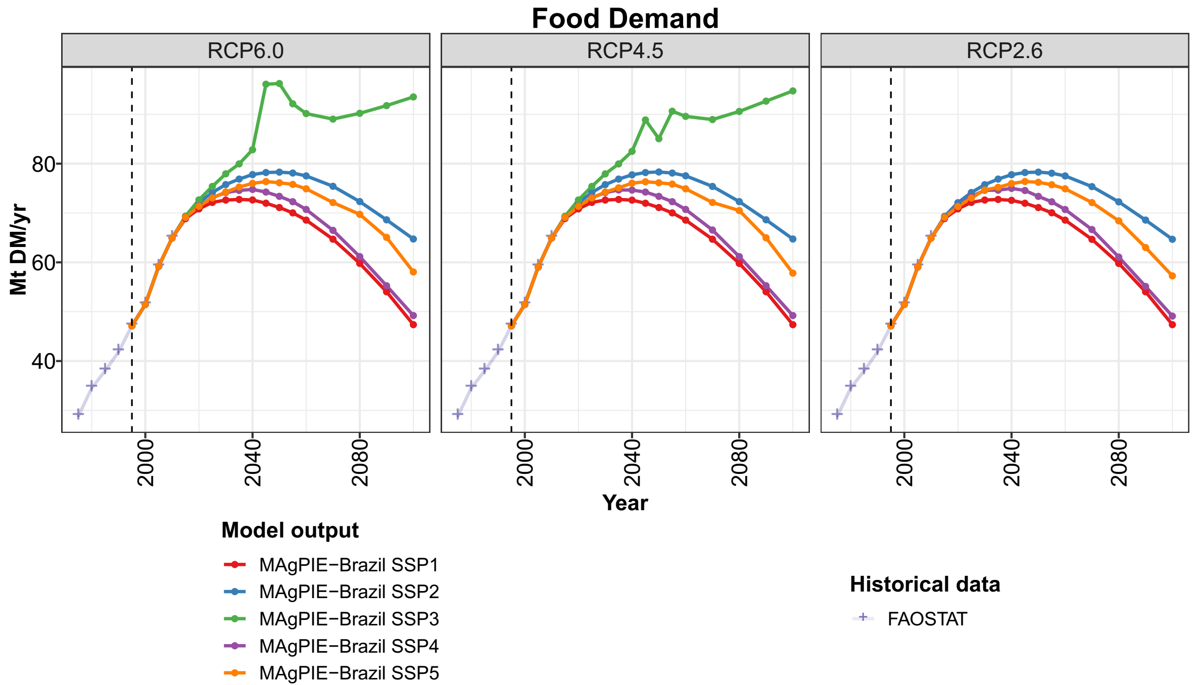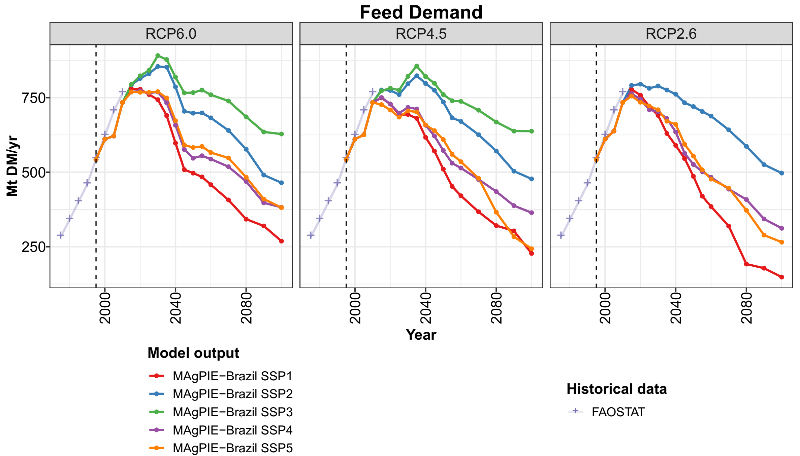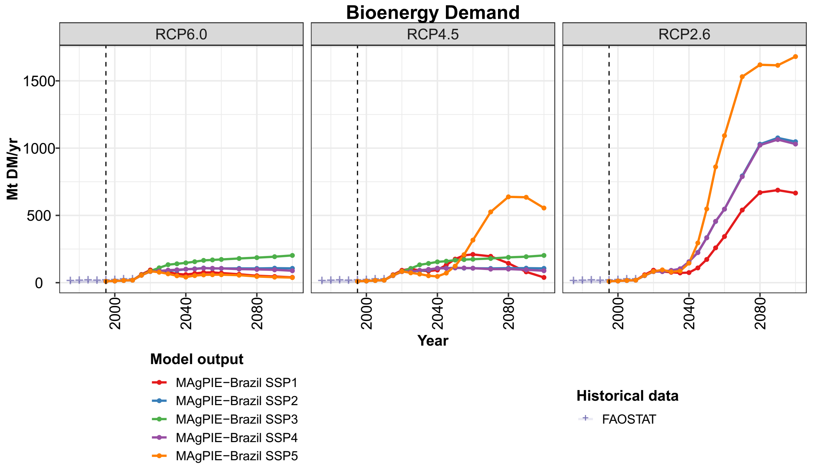

Figure 2. Brazilian food, feed and bioenergy demand.

*Other land* validation data from FAOSTAT is not available in MAgPIE’s validation datasets. The historical dataset for this land type is LUHv2v, whose value is much higher than MAgPIE’s projections (Figure 4). Even though there is a mismatch, both of them decreased at a similar path from 1995 to 2010: 7.5 million ha in MAgPIE-Brazil and 7.1 million ha in LUHv2v. For most of the RCP-SSP scenarios, *other land* remains constant from 2015 onwards and only present some increase in SSP1 and some decrease in SSP3. *Other land* share decreases in parts of Southeast and Northeast and this effect is higher in RCP6.0-SSP2.

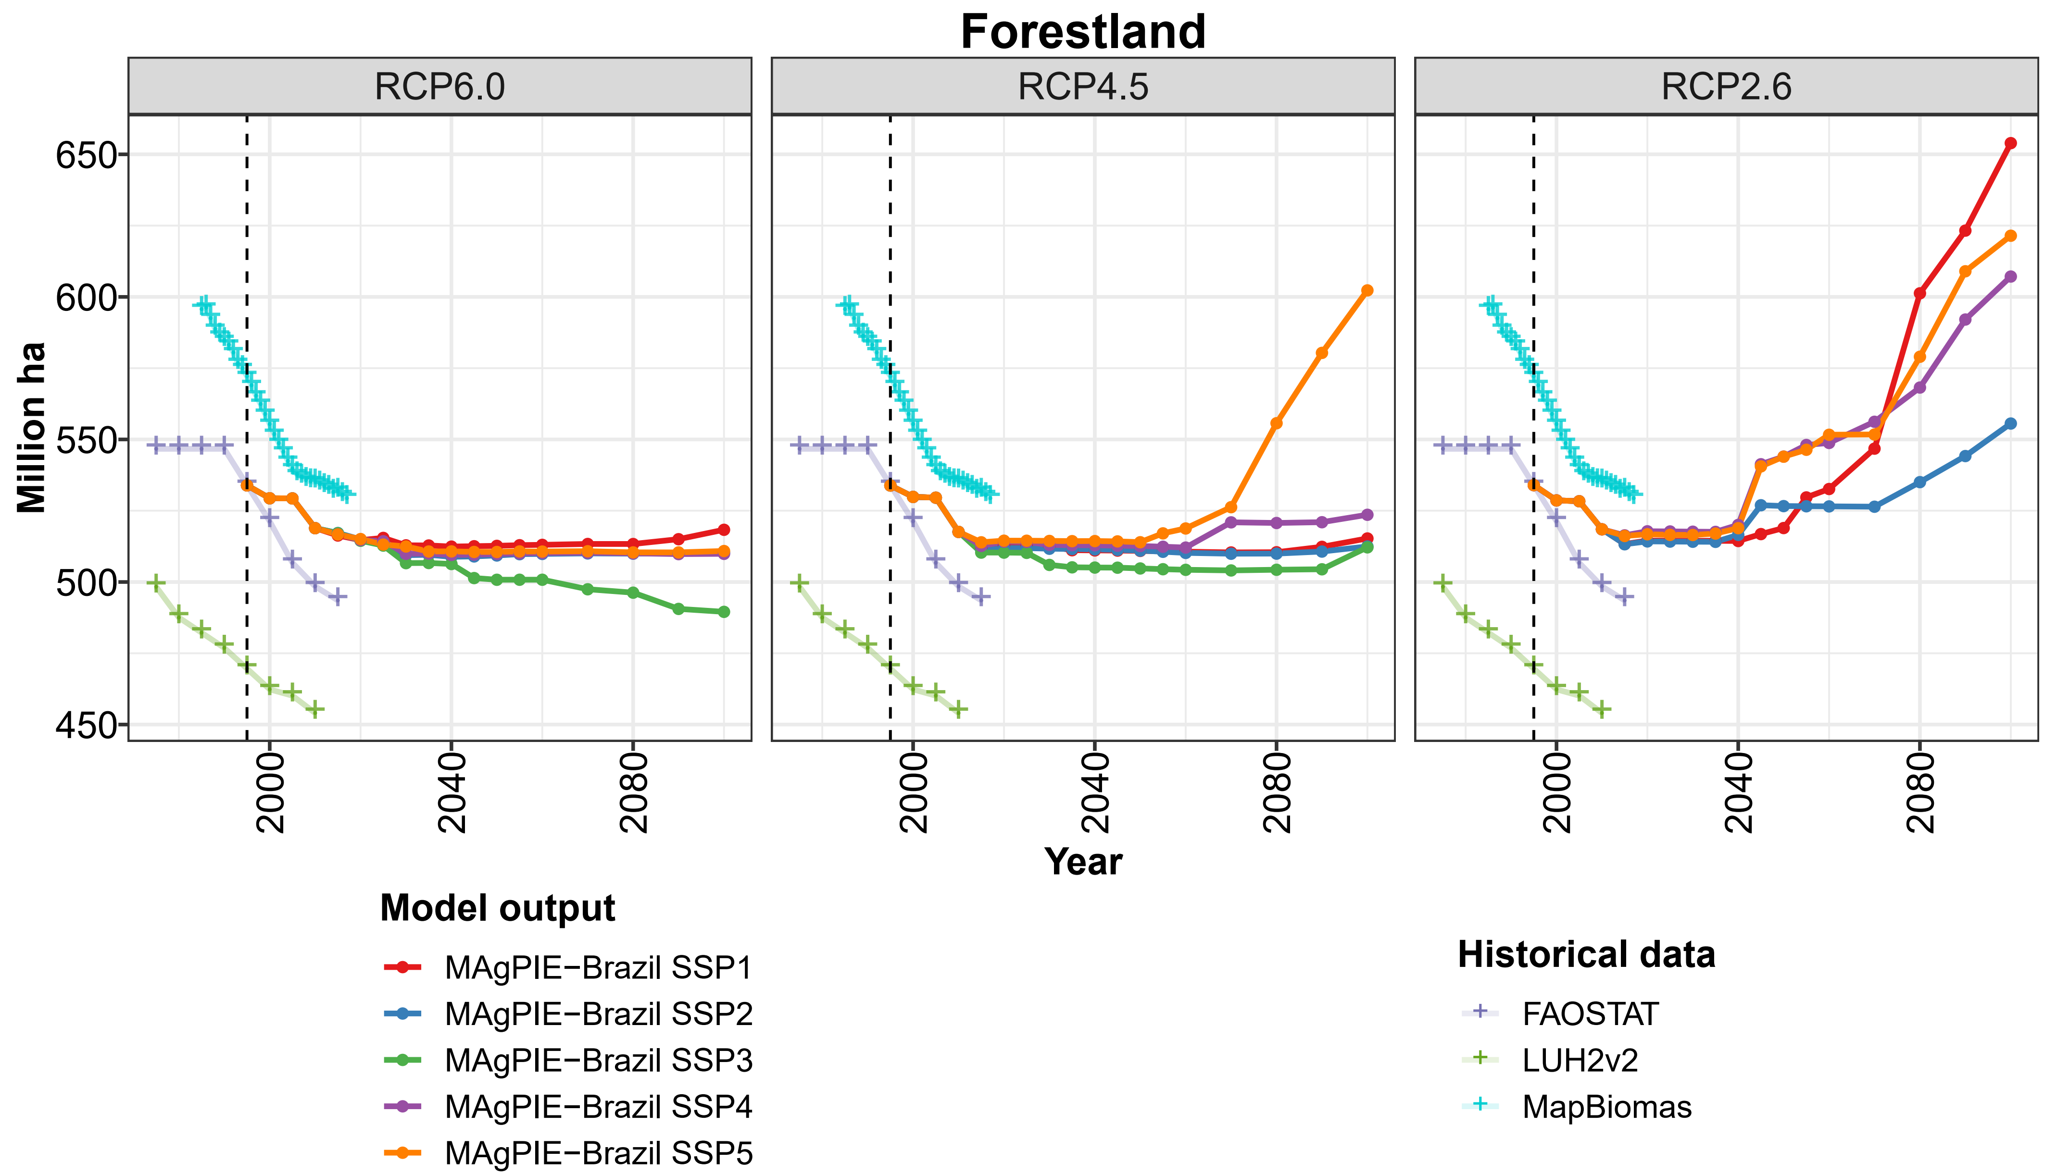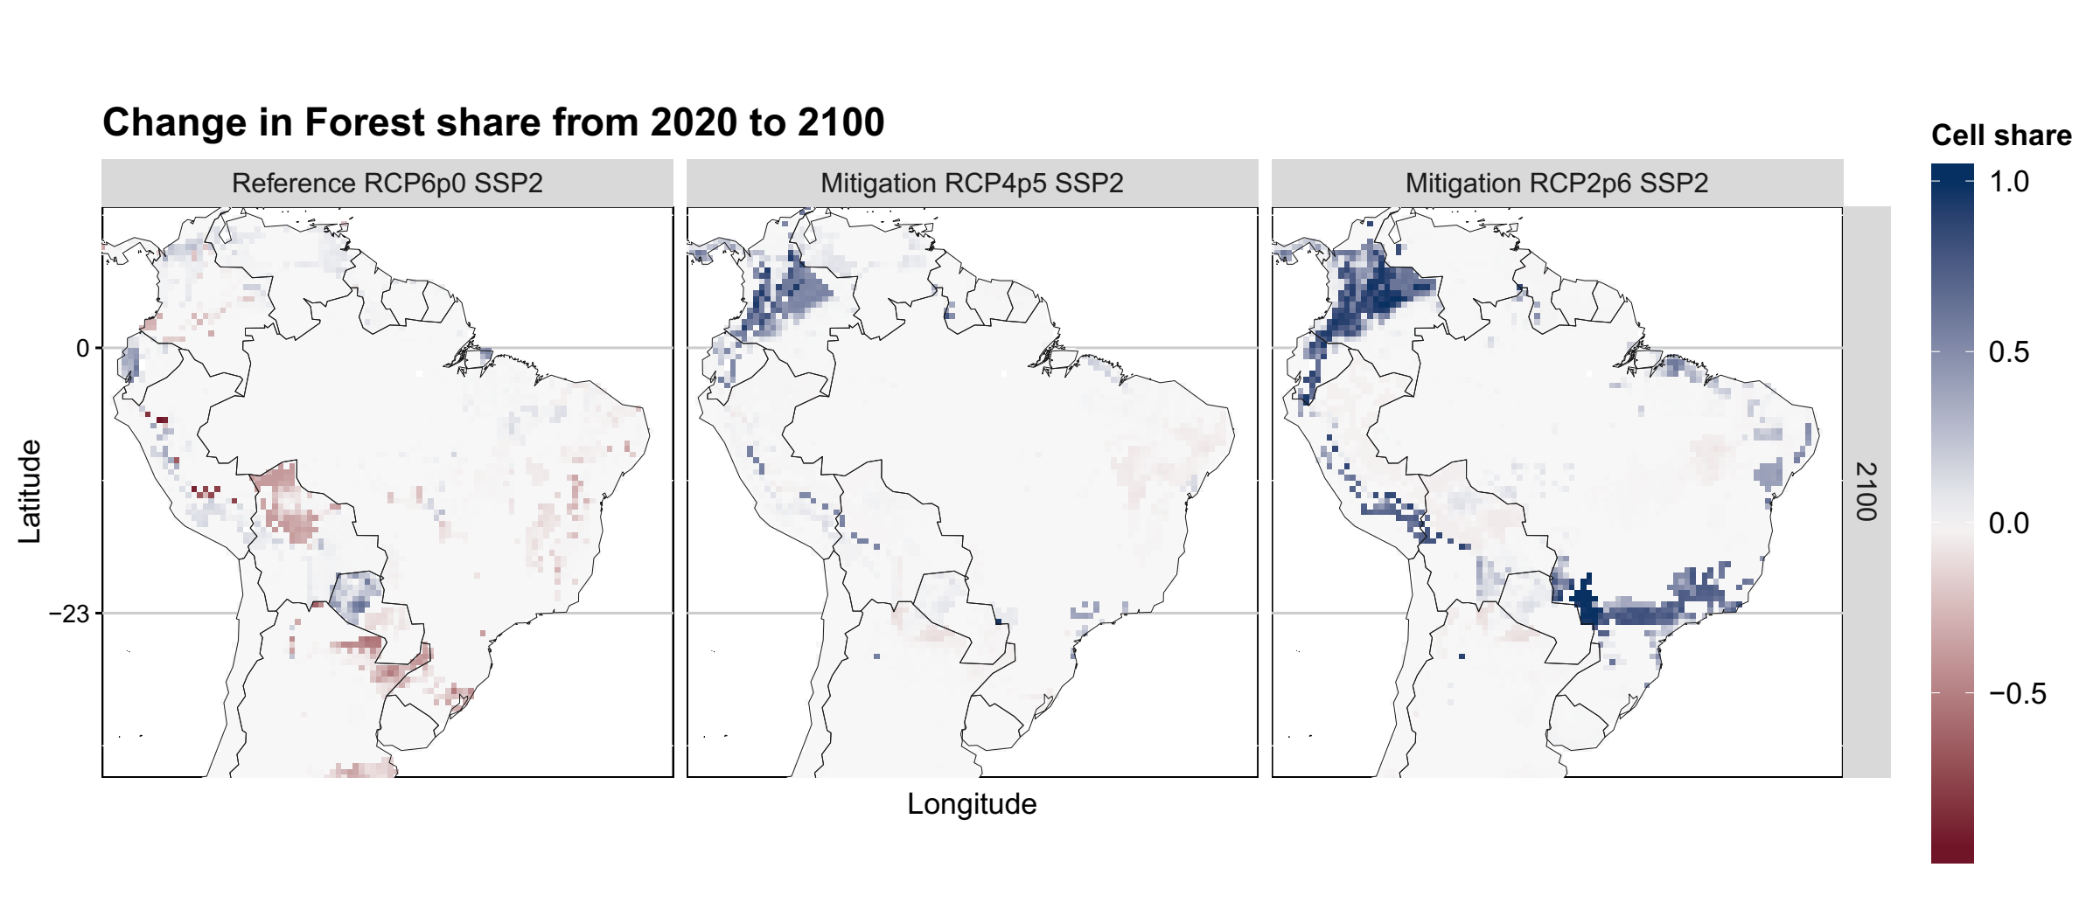

Figure 3. Brazilian forestland and change in forest share from 2020 to 2100.

* 1. **LUC CO2 Emissions**

Figure 5 shows cumulative emissions from 1995 to 2100. Although deforestation stops around 2030 in most of scenarios, LUC CO2 emission remains positive up to 2050, which reflects as increasing cumulative emission in Figure 5. From 2050 onward, LUC emissions stabilize or become negative in most of the scenarios, reflecting as stable or decreasing cumulative CO2 emissions in Figure 5. From 1995 to 2100, Brazil is projected to accumulate between 9 to 22 Gt CO2 from LUC in the atmosphere in the RCP6.0 and to sink between 2 to 14 Gt CO2 from LUC in RCP2.6 (as a consequence of the increase in forestland, see Figure 3). An interesting dynamic occurs in RCP4.5 and RCP2.6. In these RCPs, the SSP1 pathways remain above the SSP2 pathways for most of the period. It indicates that the optimal trajectory in the less demanding socioeconomic assumptions (SSP1) allows keeping higher emissions to achieve the RCP than inSSP2 (which is more socioeconomic demanding than SSP1).

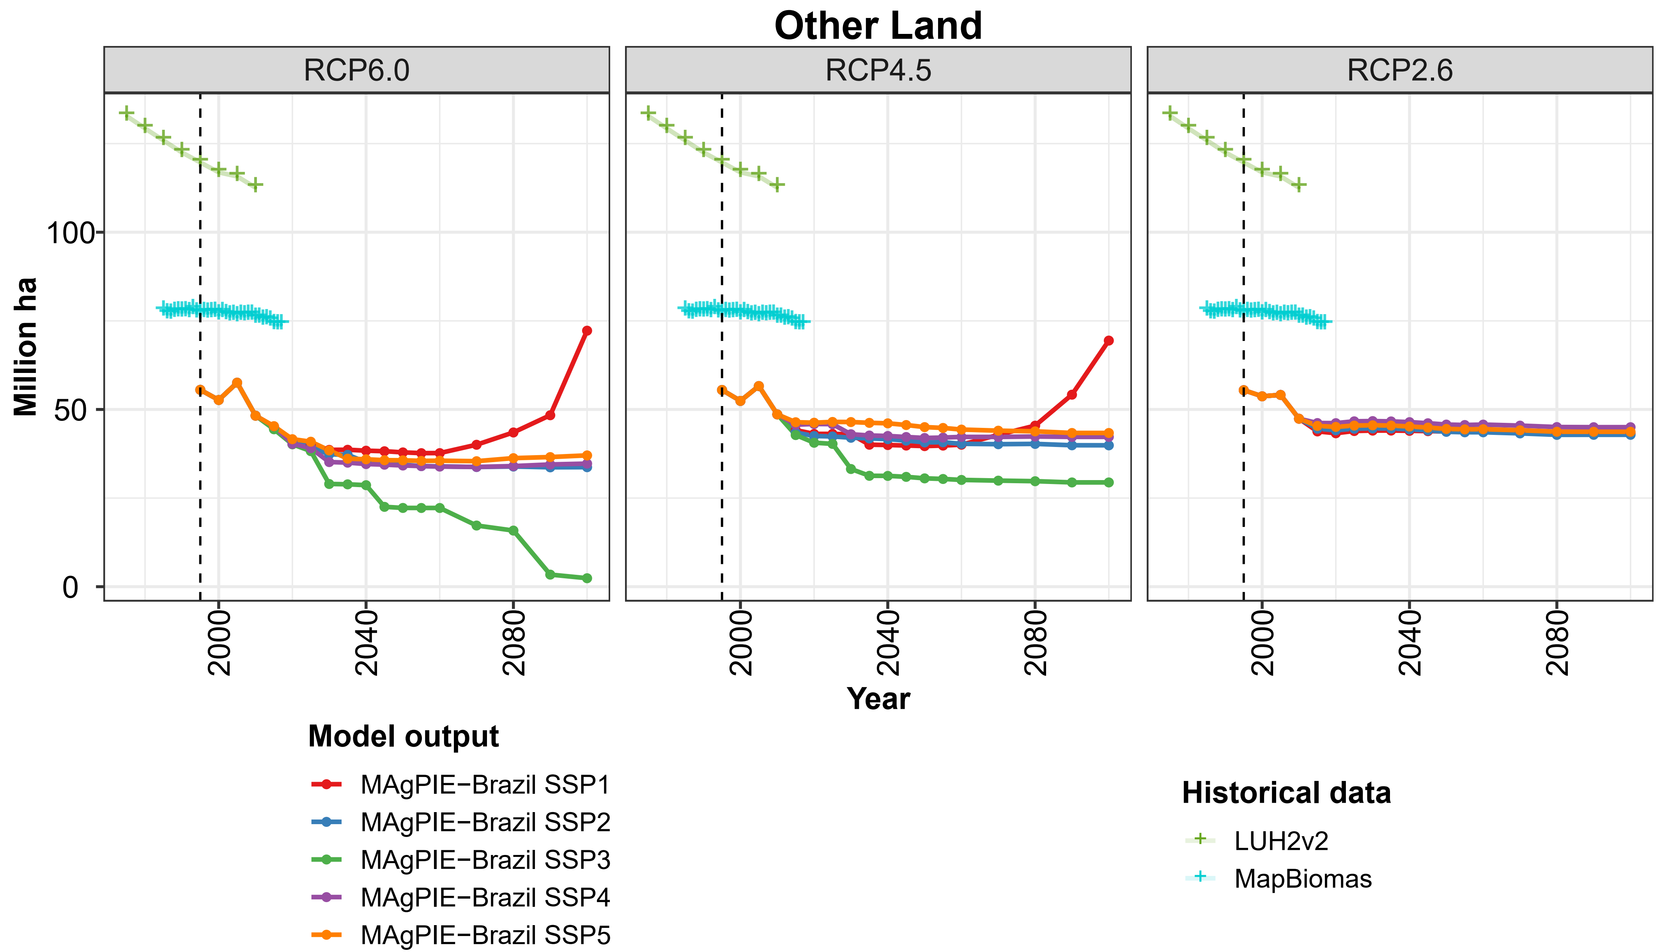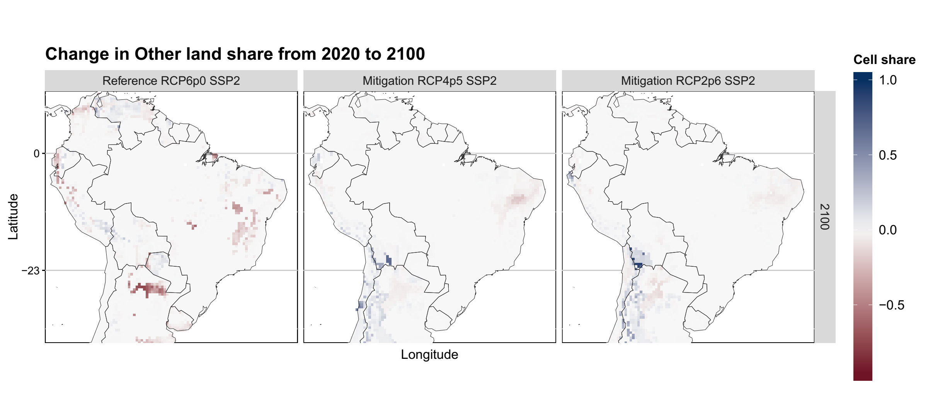

Figure 4. Brazilian other land and change in other land share from 2020 to 2100.

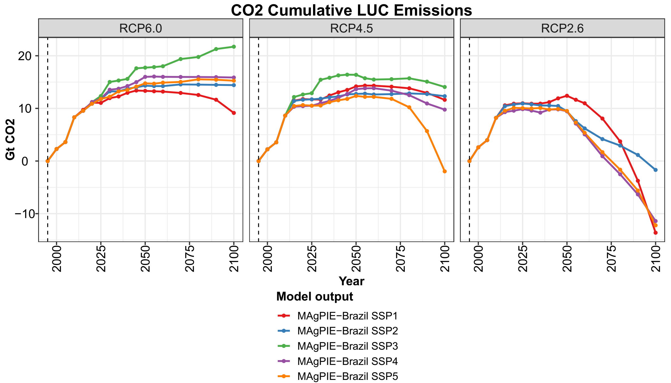

Figure 5. Brazilian CO2 cumulative LUC emissions.

* 1. **Agricultural Land**

Brazilian agricultural land (*cropland* plus *pastureland*) increases 9% in MAgPIE-Brazil from 1995 to 2010 and 6.6% in FAOSTAT and 21% in MapBiomas (MAPBIOMAS, 2019) in the same period. The initial agricultural area in 1995 is lower in MapBiomas (198 million ha) than in FAOSTAT and MAgPIE-Brazil (258 million ha). MAgPIE’s projections are designed to match as closely as possible to FAOSTAT data in 1995 in order to assure a global land-use data set, which leads to mismatching MapBiomas observed data.

Figure 6 presents *cropland* for food, feed and bioenergy crops. *Cropland* projections follow a similar path in the initial years compared to FAOSTAT and LUH2v2. In RCP4.5 and RCP2.6, the pathways remain roughly similar among the diverse SSPs after the initial years, and in RCP6.0, the pathways are wider. For RCP4.5, the projections are more concise among diverse SSPs, ranging from 100 to 130 million ha and, for RCP2.6, from 60 to 70 million ha. For RCP4.5 and RCP2.6, the peak of cropland is around 2050 for all SSPs. In RCP6.0, *cropland* range from 85 to 160 million ha in 2100. The higher increase in RCP6.0-SSP3, which has also higher food and feed demand. On the other side, *cropland* decreases in RCP6.0-SSP1 from 2060 onwards and the abandoned *cropland* becomes *other land*. As an overall outcome, the variability of SSPs is narrow in the *mitigation* scenarios.

Bottom figures in Figure 6 show that the food/feed *cropland* share increases in the South, Southeast and Northeast (especially in Caatinga biome) in RCP6.0-SSP2 and RCP4.5-SSP2. On the other side, in RCP2.6-SSP2, *cropland* share decreases in most of the country, but still increases in the Caatinga region. The Northeast region has lower yields than other regions (data not presented) and a considerable part of *cropland* expansion observed in Figure 6 is only achievable due to irrigation. In all RCPs, *cropland* expands over the same area in which Figure 3 and Figure 4 present *forestland* and *other land* decreases, indicating deforestation and depletion of natural land. Bioenergy *cropland* share increases in South in RCP2.6-SSP2 but its changes in RCP6.0 and RCP4.5 are almost negligible. Most of *cropland* share decreases in RCP2.6-SSP2 is due to *pastureland* expansion (presented later in Figure 7).

MAgPIE’s *pastureland* projections (Figure 7) present a negative spike from 2000 to 2005 that disconnect projections from historical data. Low yield pastures in South motivate the abandonment of pasture in the region, which can be the cause makes forest stock to stay stable while historical data keeps decreasing in the same period in roughly constant forest stock in the same period (Figure 3). The decrease in *pastureland* is of about 15 million ha and it is partially compensated immediately after. The projections after 2010 do not present any similar spike and follow a decreasing pathway. *Pastureland* has already peaked in all RCP-SSP scenarios, except RCP6.0-SSP3, and a robust decrease is expected in most of the scenarios.

*Pastureland* in RCP2.6-SSP2 presents a particularly interesting dynamic. In this scenario, *pastureland* in Brazil decreases from 2035-2045 (15 million ha) and then restarts to increase from 2045-2070 (20 million ha). From 2020 to 2045, *pastureland* share decreases in the South, Southeast, and Northeast but remain unchanged in Center-West (data not presented). From 2045 to 2100, *pastureland* share increases in Center-West, Southeast and MATOPIBA (data not presented). In addition, *cropland* decreases from 2045 to 2055 (Figure 6), which also indicates conversion from *cropland* to *pastureland*. At the international level, *pastureland* decreases in all regions except Europe and Food/Feed *cropland* decreases in all regions. On the other side, from 2050 onward, managed forestland increases for all regions (except Europe and USA) and bioenergy *cropland* increases more for the other regions than for Brazil from 2040 onwards. Concomitant to all these international dynamics, Brazil is the only region where *pastureland* increases. The geographical dynamics of the period demonstrates afforestation and bioenergy crops taking over *pastureland* in South America. Forest share increases in Colombia and Ecuador (Figure 3) and bioenergy crops share increases in Uruguay, Argentine and the South of Brasil (Figure 6) in the same spots where Figure 7 presents decreases in *pastureland* share. The increasing in Brazilian *pastureland* after 2045 may be a consequence of the increasing demand for bioenergy crops, which starts to increase rapidly in Brazil after 2040 (see Figure 2), and international pasture relocation to Brazil. Bioenergy crop and afforestation may take over less productive *pastureland* and push pasture to highly productive areas, such as those with increased *pastureland* share in the Center-West Brazil (Figure 7).

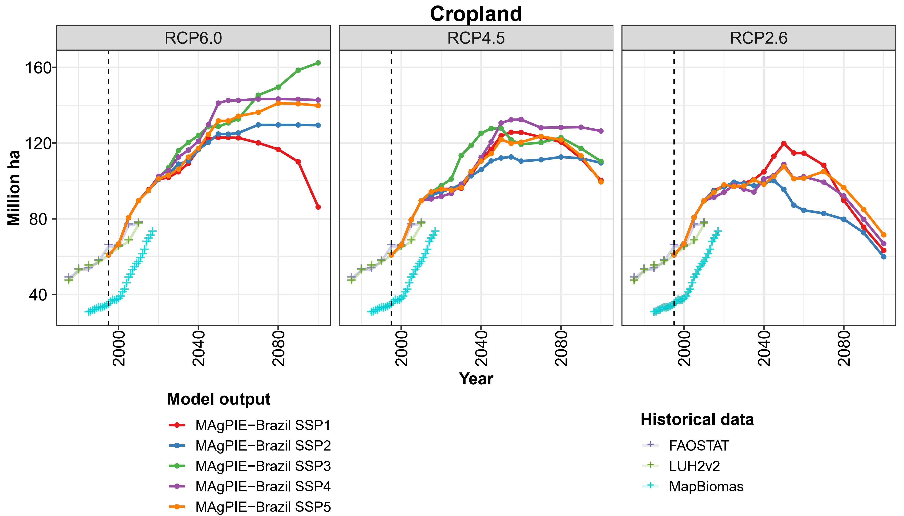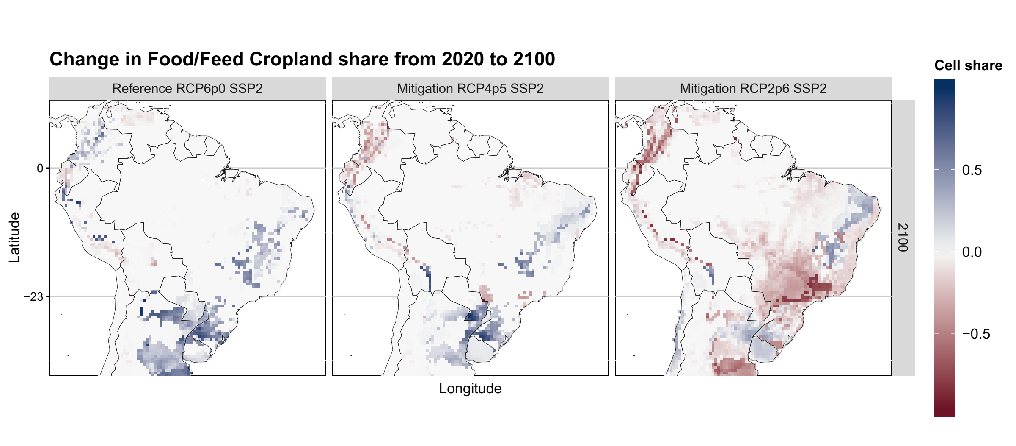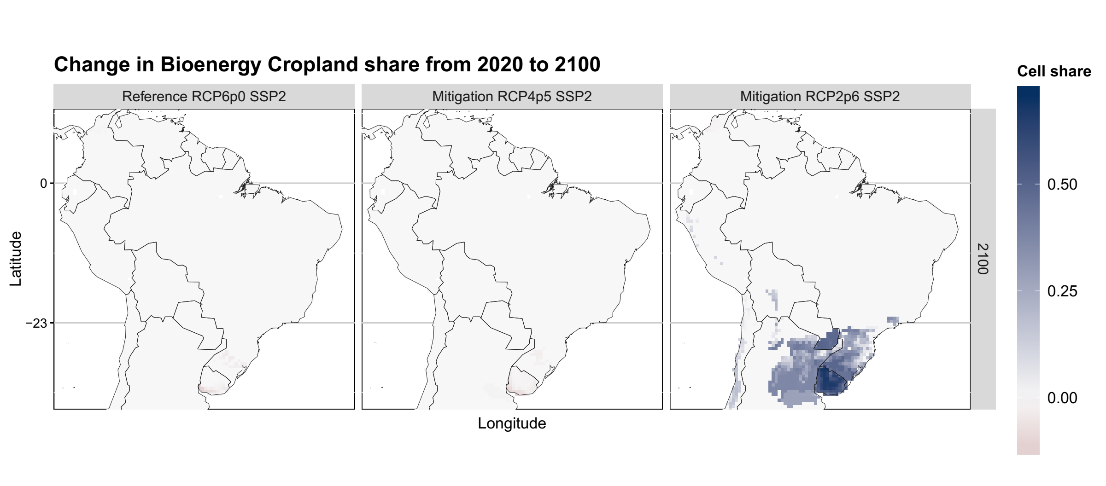

Figure 6. Brazilian cropland, change in food/feed and bioenergy share from 2020 to 2100.

* 1. **Production, yields, trade, and food price**

Figure 8 presents production of Food/Feed crops, ruminant meat and bioenergy crops. MAgPIE’s Brazilian crop production perfectly matches FAOSTATS historical data. The crop productions peaks at 2050 in most of the RCP-SSP scenarios. With the exception of SSP3 scenarios, Brazilian food/feed crops production pathways are similar in all RCP-SSP scenarios and reach 2100 with between 375 Mt DM and 665 Mt DM. Ruminant meat projections disconnect from historical data in the initial years due to the pastureland decrease observed in Figure 7. It peaks between 2035 and 2040 in most of scenarios and then decreases. Ruminant meat production decreases from 2040 onward in most of the scenarios as following the decreases in Brazilian food and feed demand (Figure 2). Bioenergy crop production follows a path similar to the Brazilian demand for it. In general, Figure 8 depicts the role of demand in defining production, as it follows roughly the same path presented in Figure 2. It is noteworthy the increasing relative importance that bioenergy crops presents related to food/feed crops in RCP2.6. In the RCP2.6-SSP2, for example, Food/Feed Crop Production peaks at 700 Mt DM in 2050. Bioenergy Crop Production, by its turn, is 294 Mt DM in 2050 and peaks at 1238 Mt DM in 2090.

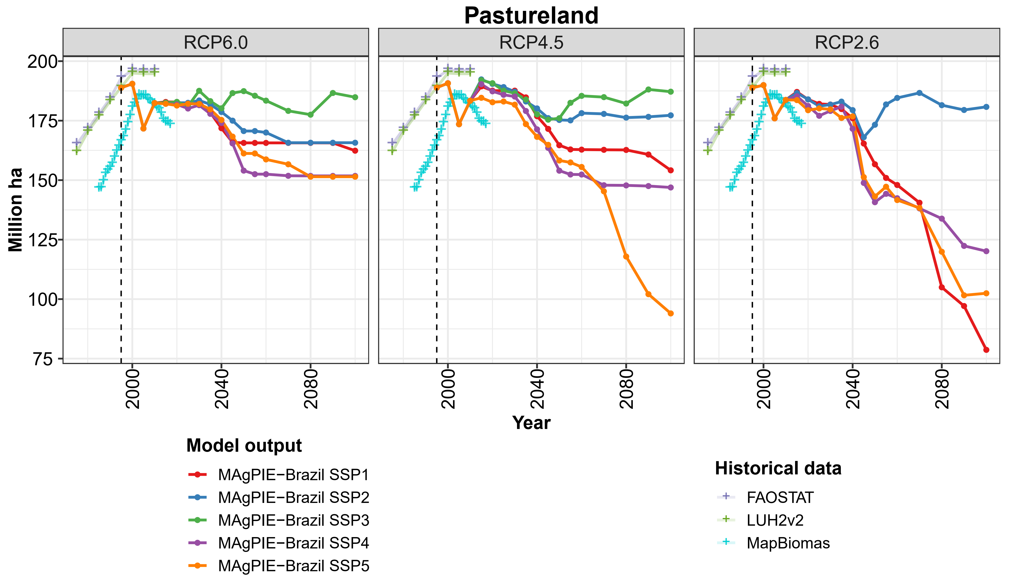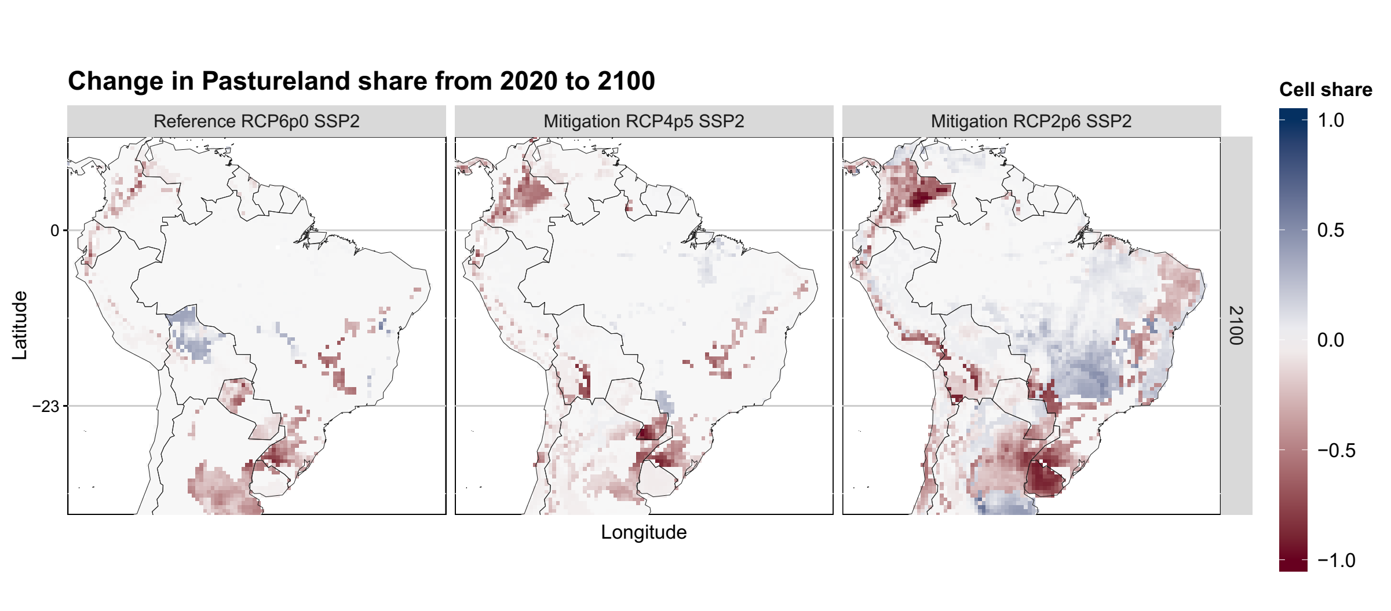

Figure 7. Brazilian pastureland and change in pastureland from 2020 to 2100.

Figure 9 presents crop and pasture yields. SSP1 scenarios depict socioeconomic features of a sustainable development world with lower demand, which requires less intensification. *Mitigation* scenarios, by its turn, imply higher land use for afforestation and for bioenergy crops, which means higher land competition and relative advantage to invest in technological changes when comparing to *No-Mitigation*. However, investments in technological change to increase yields as a response to land scarcity is only captured by crops, which have an endogenous implementation (DIETRICH *et al*., 2014). Pasture yields, by its turn, can only increase as a response to higher demands and this is depicted by the results in Figure 9. Pasture yield follows a path similar to feed demand (Figure 2) and present high productivity in SSP2 and SSP3, the ones with higher food and feed demand. As the model can only respond to land scarcity with more pasture expansion, it is possible that the decreases in pasture yields are also due to land expansion towards low productive areas. Most of the pasture yield pathways have already peaked and shall follow a decreasing path now on, but this can be more a model artifact than a robust result.

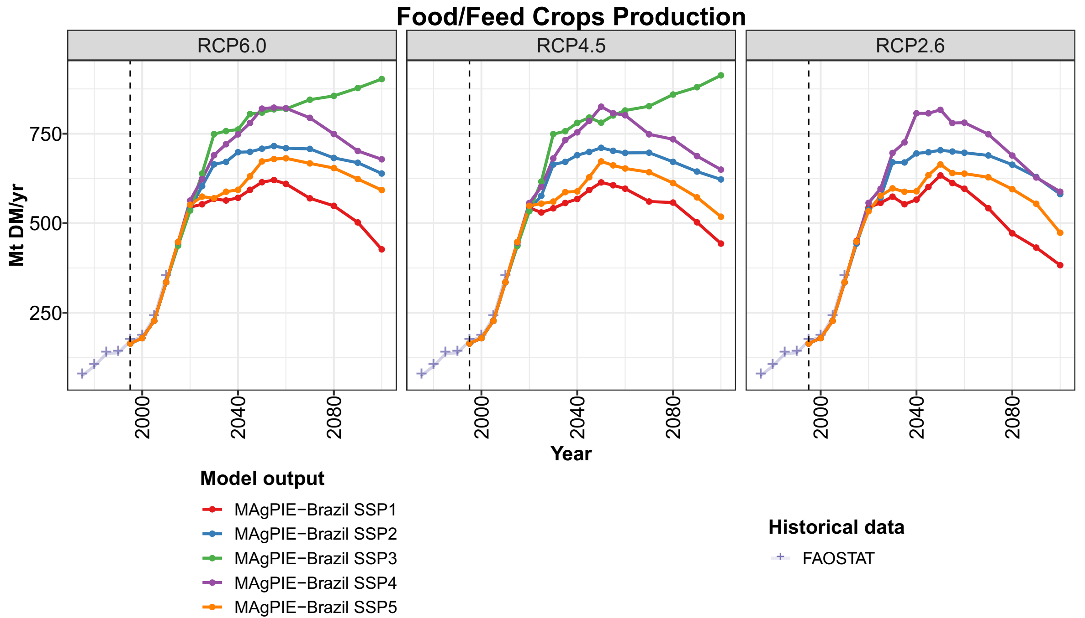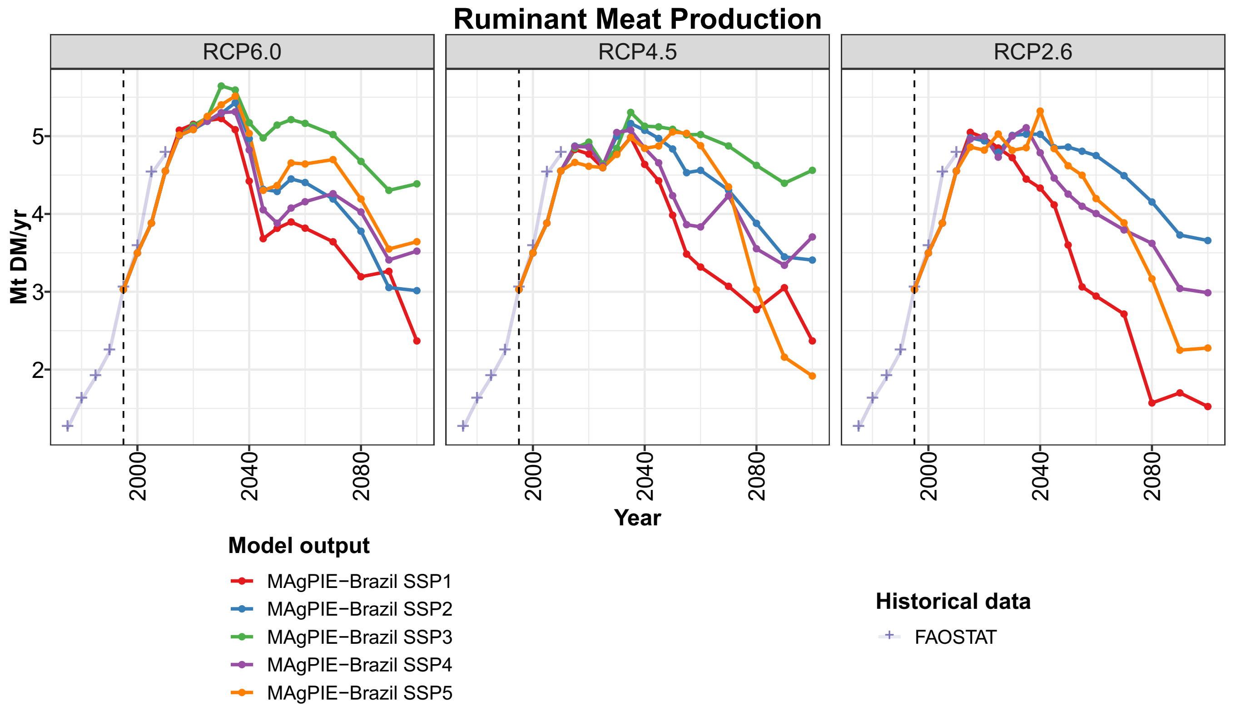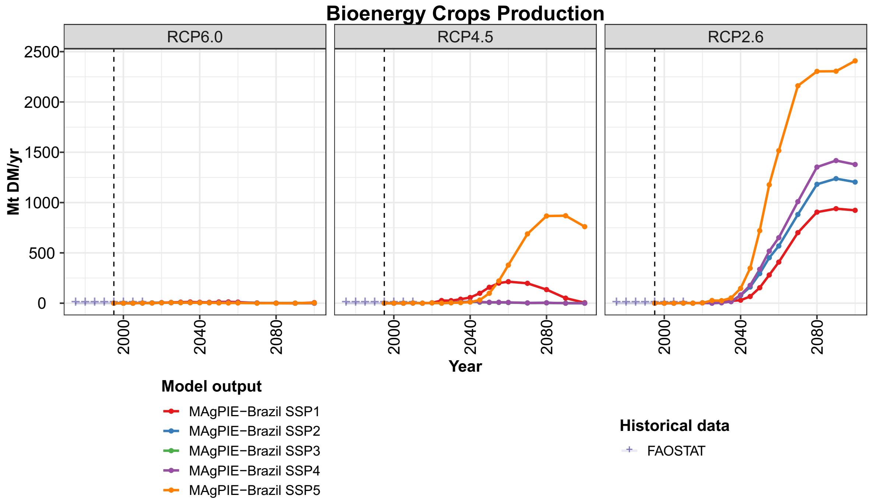

Figure 8. Brazilian food/feed crops, ruminant meat and bioenergy crops production.

Figure 10 presents how Brazil would benefit and disadvantage from climate change from different perspectives. Brazilian Net-Trade increases as moving towards RCP2.6 mainly due to bioenergy crops exports, which accounts for 60% of Brazilian exports in RCP2.6-SSP2 in 2100 and 83% in RCP2.6-SSP5. The structural changes related to RCP2.6 imply that Brazil, China, Europe and the USA become high producers and exporters of bioenergy crops (data not presented). On the other side, Brazilian food prices increase exponentially for most of the SSPs in the RCP2.6 and much more than compared to other MAgPIE-Brazil’s regions in this RCP. The land competition between food/feed crops, pastureland, and bioenergy crops pushes up food prices especially in Brazil, as the country is an important producer of all these products. In RCP2.6-SSP2, as presented in Figure 7, such global competition pushes pastureland back to Center-West after 2045 and this is the scenario with the highest food price index increase. The RCP2.6-SSP1, on the other side, presents the lower increase in Brazilian food price in RCP2.6, although it has one of the lowest Net-Trade. As the price elasticity of demand for major food categories is inelastic (ANDREYEVA; LONG; BROWNELL, 2010), it is likely that the increasing prices affect the poorest the most, as they have to spend a higher share of their income in food products.

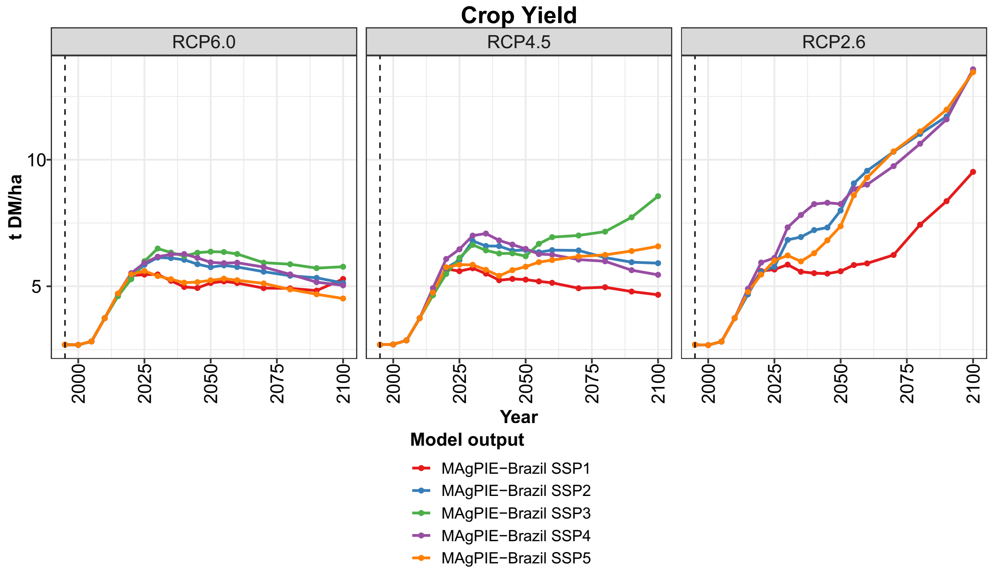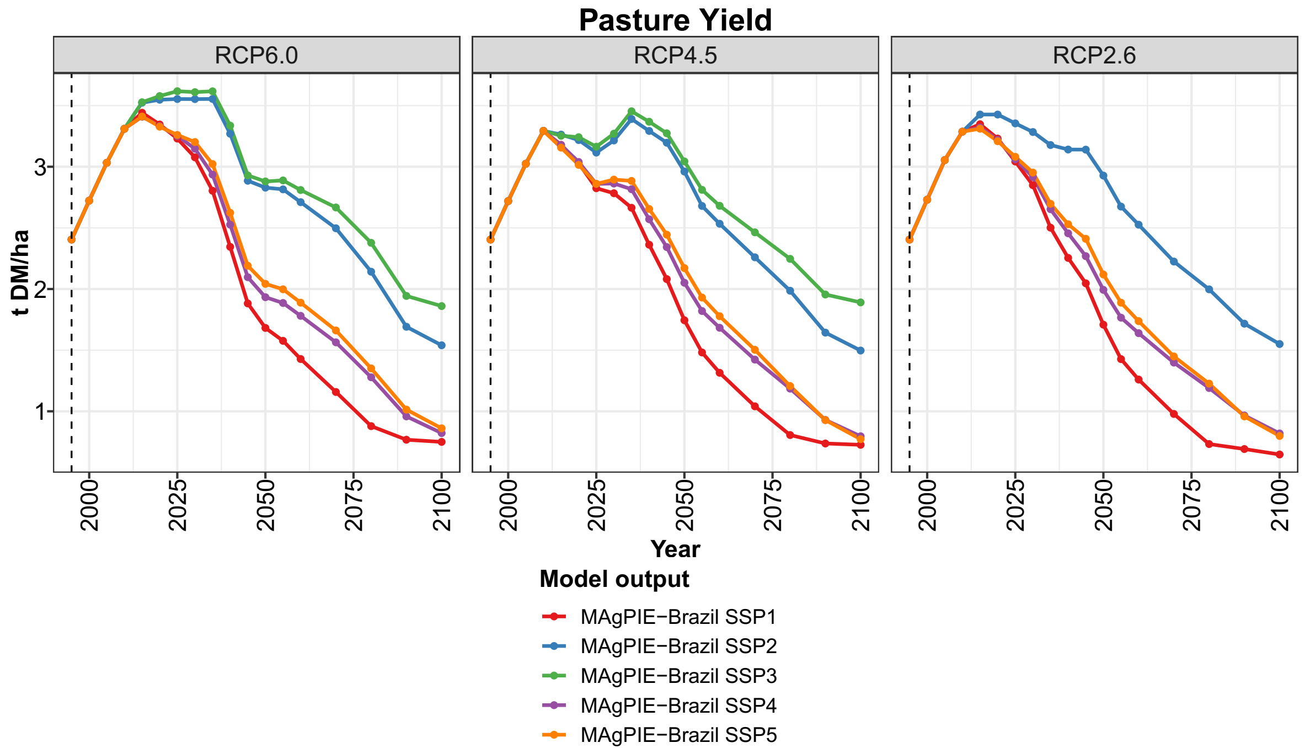

Figure 9. Brazilian crop and pasture yields.

In an overview, Figure 10 depicts orthogonal effects even in the *mitigation* scenarios: from the perspective of the market, there are opportunities for exports; from the perspective of the consumer, the increase in food prices has to be dealt with. In the end, the described effects from Figure 10 have to be set in the perspective of pasture yields, which would be higher if the model were able to account for intensification as a reaction for land scarcity and not only to increase cattle density as a response to increases in demand. If the model invests more in pasture intensification, it would require less pastureland and, therefore, it would soften the effects that land competition has on food prices.

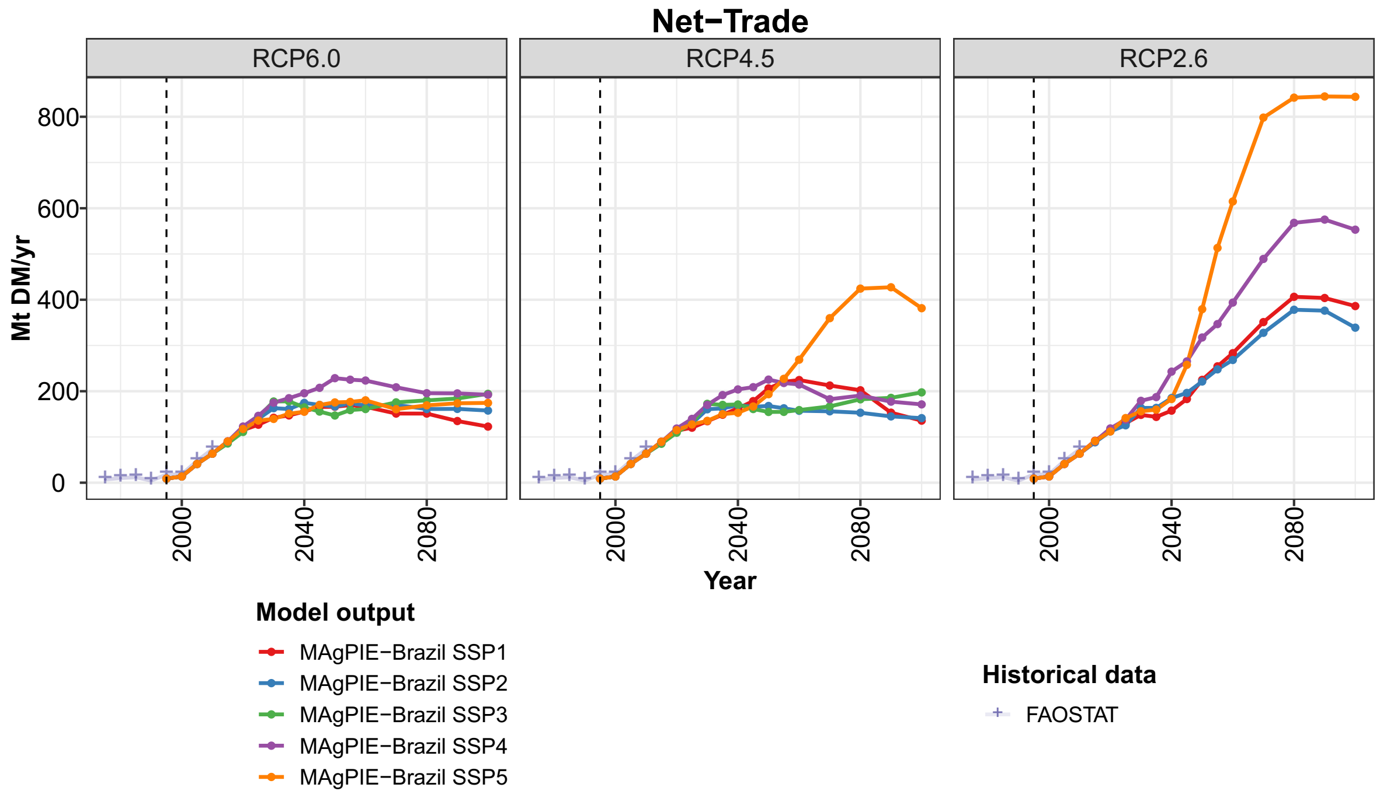 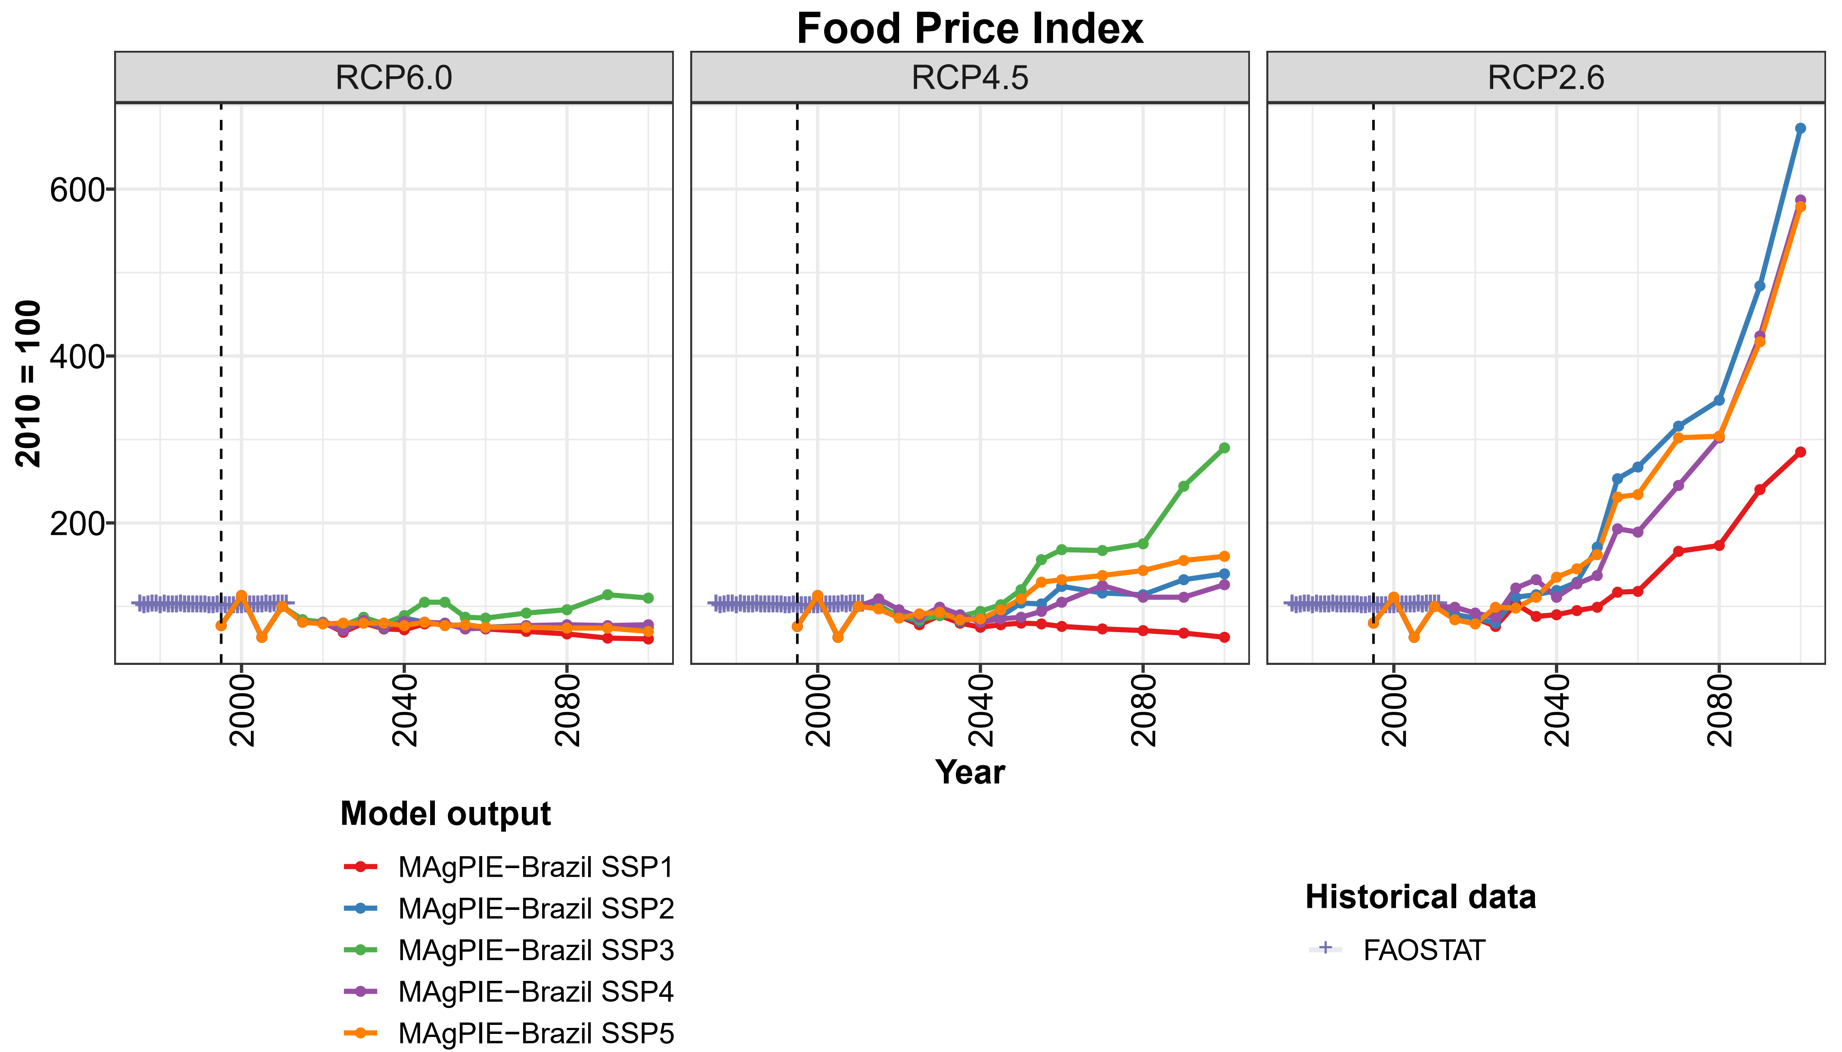

Figure 10. Brazilian net-trade and food price index.

1. **DISCUSSIONS**

Brazilian land use evolves in diverse pathways depending on the socioeconomic and biophysical assumptions, which are important drivers of demand. Demand varies widely across the SSPs. Food and feed demand are higher in SSP3 and lower in SSP1 in Brazil and globally. High variability in global demand in diverse SSPs has also been assessed by Integrated Assessment Models, which include other dynamics than land use (POPP *et al*., 2017). High Brazilian demand in SSP3 scenarios posit opportunities for production that result in pressure for deforestation, while the low demand in SSP1 scenarios incentivizes abandonment of agricultural land and regrowth of natural land. Food and feed demand in SSP2 is lower than in SSP3 and higher than in the others. The pathway of population projection in SSP2 is the closest to the Brazilian official projection (IBGE, 2019), enhancing its reliability. Food and feed demand in RCP2.6-SSP2 is the highest because RCP2.6 is infeasible with the socioeconomic assumptions of SSP3. By one side, this scenario presents high pressure for deforestation in RCP2.6, but on the other side, the Carbon Emission Prices disincentive deforestation. As a result, RCP2.6-SSP2 is the one where relatively high socioeconomic demands are concomitant with environmental sustainability, consolidating two diverse development aims. However, the scenario where both aims are met implies the highest and fast increasing Brazilian food prices. This increase is motivated by boosting land competition due to afforestation and bioenergy production. Large-scale bioenergy production without complementary measures may incentive adverse side effects to deforestation, CO2 emissions from LUC and food prices (HUMPENÖDER *et al*., 2018). Therefore, following RCP2.6-SSP2 will require policies to soften the undesired increase in food prices, such as enhancing technological changes investments. Similar investments were done before, in the 1960s and increased soybean yields in the 1970s (PASTORE; DA SILVA DIAS; DE CASTRO, 1976). The increase in Total Factors Productivity (GASQUES; BACCHI; BASTOS, 2018) from the 1970s to the 2000s and agricultural intensification from 1990 to 2012 (DIAS *et al*., 2016) have the potential to reduce production cost and to allow for reducing food prices in all scenarios.

Production and land-use pathways have been assessed in previous Brazilian research in SSP2 by the impacts of the compliance of the Forest Code. However, these studies had no assessment of the effects that diverse biophysical and socioeconomic assumptions could have (CAMARA et al., 2015; SOTERRONI et al., 2018b) or presented a limited set of biophysical scenarios (ZILLI *et al*., 2018). By evaluating 14 different RCP-SSP scenarios, the present research demonstrates the diversity of Brazilian production, land use, food price, and trade pathways. In a general overview, cropland production increases up to 2050, ruminant meat production increases up to 2035 and bioenergy crops production starts increasing only in the mitigation scenarios, from 2040 onwards.

Cropland expansion to the Northeast in SSP2 occurs in all RCPs from 2020 to 2100, mainly in Caatinga. This result is similar to GLOBIOM-Brazil’s result, which projects cropland expansion towards Northeast, mainly in MATOPIBA, from 2010 to 2050 in SSP2 (SOTERRONI et al., 2018b). The divergence in the focus of cropland expansion in both studies can be because MAgPIE-Brazil assumes considerably reduced deforestation in Legal Amazon, whose area partially overlaps MATOPIBA. The dynamics projected by MAgPIE-Brazil may enhance regional development but raise environmental concerns. This region is historically less developed than the South, Southeast, and Center-West and the agricultural expansion there brings economic opportunities. Moreover, cropland expansion takes over *other land* and abandoned *pastureland*, which implies less Carbon emission than if it were forestland. On the other side, the region has been under water stress and water value may increase in the next decades (ALCOFORADO DE MORAES *et al*., 2018). Even though this cropland expansion may bring economic opportunities at relatively less Carbon emission, the long-term impacts of water demand in a water-stressed area are able to offset such benefits. More research, however, is necessary to understand how water stress would affect the local economic development.

Cropland expansion to the South in SSP2 is mainly due to rainfed maize production in RCP6.0 and RCP4.5 and due to bioenergy grains in RCP2.6. Brazilian maize production increases roughly 60% in RCP6.0-SSP2 and RCP4.5-SSP2 from 2010 to 2050. The increase in the area of maize plantations was observed before in the 1990s and 2010s (DIAS *et al*., 2016). Brazilian bioenergy production increased from 15.4 Mt DM in 2035 to 1250 Mt DM in 2090 in RCP2.6-SSP2. Such increase represents the establishment of a new dynamic that has not been observed before. Bioenergy exports are 250 Mt DM in 2090 in RCP2.6-SSP2 and 700 Mt DM in 2090 in RCP2.6-SSP5. Large-scale bioenergy production may be associated to increasing deforestation and CO2 emissions from LUC (HUMPENÖDER *et al*., 2018), but bioenergy crops expansion to the South occurs over abandoned pastureland, which potentially minimizes such effect. Afforestation also increases in the South region and close to the bioenergy crop plantation. However, afforestation and bioenergy crops increase in this region is likely due to an unusual low pasture yields there used as input for MAgPIE-Brazil (data not presented). Further research is required to conclude whether or not the low pasture yield used as input is reliable. If so, MAgPIE-Brazil’s result indicates an opportunity of sustainable usage of these new forest areas, extending the range of economic activities in the South. In addition, land competition there could be one reason for the extreme increase in food prices observed in RCP2.6-SSP2.

Agricultural land use may remain as an important economic activity in Center-West in the next decades. The region experienced agricultural extensification over decades due to maize and soybean (DIAS *et al*., 2016). MAgPIE-Brazil projects expansion of pastureland (only in RCP2.6-SSP2), rainfed maize, rainfed soybean and, at a smaller scale, irrigated sugar cane during this century. Results from GLOBIOM-Brazil also indicate cropland expansion in the region (SOTERRONI et al., 2018b). Cropland dynamics in the Center-West relates more to products relocation than to deforestation of forestland. Maize and soybean expand more to the central area of Center-West while sugar cane expands to the southwestern of Cerrado biome, in the movement already hypothesized by Carvalho; De Marco and Ferreira (2009). Future agricultural dynamics in Center-West are similar to the current ones, as it remains an important crop and livestock producer. In general, the policy challenges are to avail the region’s agricultural suitability while protecting Cerrado and Amazon ecosystems. In the scenarios of SSP3, the agricultural land use in Center-West is more robust and shall require more policies to avoid depletion of natural land. In the scenarios of SSP1, agricultural land is less robust and there are future opportunities for sustainable use of afforested areas in the southern of Center-West.

Brazilian pastureland stays roughly stable in all RCP-SSP scenarios between 2010 (≅ 183 million ha) and 2030 (between 188 and 179 million ha) and follows decreasing pathways afterward in most of the scenarios. This overall decrease in pastureland was depicted by GLOBIOM-Brazil in SSP2, yet, they accounted for decreases in southern Cerrado and the coast of Southeast from 2010 to 2050 (SOTERRONI et al., 2018b), while results here state no significant changes in *pastureland* share in these areas from 2020 to 2100. The implementation of livestock production differs in both models. GLOBIOM-Brazil accounts for different ruminant meat production systems ranging from less to more intensive while the diverse ruminant meat production in MAgPIE-Brazil can only intensify pasture production due to changes in demand (not due to land scarcity). This methodological difference can explain why GLOBIOM-Brazil presents pastureland decreases in areas where MAgPIE-Brazil has no significant changes in *pastureland* share. The dynamics of relocating pastureland from the South region towards the southern of Amazon biome is consistent in both models. Livestock expansion to Amazon biome has been reported in the last decades (DIAS *et al*., 2016) and MAgPIE-Brazil projects this dynamic between 2000 and 2030 due to high productivity pastures there. Relocation to Center-West is a different dynamic and occurs only in RCP2.6-SSP2. This is potentially driven by international pasture relocation to Brazil due to high land competition associated with this scenario. Pastureland expansion to Center-West has not been observed since 1990 (DIAS *et al*., 2016) and its reoccurrence would be a rupture to the current trend of reducing pasture area in the region.

In the end, MAgPIE-Brazil projections for pastureland have to be set into perspective. At first, because an unusual negative spike in pastureland between 2000 and 2005, which occur due to pasture abandonment in the South region. Secondly, because of the technological change implementation for pasture in MAgPIE-Brazil that cannot capture feedbacks between land scarcity and efforts to improve pasture management. This is an important limitation because increasing cattle productivity is a required step to reduce deforestation through the enforcement of the Forest Code (SOTERRONI et al., 2018b). Model improvements and/or other methodological approaches are therefore required to enhance the reliability of such results.

Brazilian land-use dynamics will break with the trends of depletion of natural land (*forestland* and *other land*) from 2040 onwards in all RCP-SSP scenarios, but RCP6.0-SSP3. Although this result is similar to other researches (CAMARA et al., 2015; SOTERRONI et al., 2018b), it has to be taken carefully because of the discrepancy between model results and observations. Deforestation itself stops or follow a roughly declining trajectory from 2030 onwards in most of the RCP-SSP scenarios. It is important to note that the deforestation restrictions still allow for some degree of deforestation and, despite this possibility, the model finds its optimal solution with very low deforestation after 2030. The main causes for finishing deforestation can be twofold. The first is the demand, especially feed demand, which is the main driving force of production and roughly stabilizes or decreases in most scenarios after 2030. The second is cropland expansion towards abandoned pastureland instead of forestland, which is a more feasible option. Zero deforestation in the next decades is a sound result from the models perspective as it occurs in most of the RCP-SSP scenarios. However, in practice, the farmer is the one to decide for deforesting or using abandoned pastureland as land for new plantations. Although MAgPIE-Brazil simulates many biophysical and costs interactions at the cluster level, the full dynamic still depends on factors not captured by the model, such as land tenure and farmer’s legal reserve quotas. In this perspective, MAgPIE-Brazil’s zero deforestation is part of an optimal solution for the model and, therefore, provides support for policies and deeper researches aiming at it.

MAgPIE-Brazil’s projection about finishing deforestation in the next decades is similar to Soterroni; Mosnier; *et al.* (2018) projections from GLOBIOM-Brazil, which attest for little deforestation occurring in Brazil from 2030 onwards in the case of fully enforcing the Forest Code. Deforestation in Brazil depends highly on the enforcement of deforestation mitigation measures (CAMARA *et al*., 2015). The full enforcement of the deforestation mitigation targets in the present research occurs from 2020 onwards, when the NPI infer the highest constraints. Even after 2020, natural land depletion remains as an optimal alternative for agricultural land use: deforestation occurs up to 2030 and depletion of *other land* occurs up to 2040. Brazil has the commitment to stop illegal deforestation in Amazon by 2030 (BRAZIL, 2015) and the results suggest that deforestation in Amazon may stop around this period. The usage of the high-resolution deforestation monitoring to identify small deforestation sites is an important instrument to enhance the accomplishment of this aim.

From the total Brazilian GHG emissions in 2016, 57.8% were accounted by the LUC sector (SEEG, 2017), which depicts the important contribution that the sector would have on the country’s GHG mitigation. Brazilian CO2 emissions from LUC follow a similar decreasing path as deforestation and short-term commitments guide its efforts to reduce CO2 emissions. By the NPCC, Brazil committed to having CO2 emissions from Agriculture Forestry and Other Land Uses (AFOLU) sector lower than 516 Mt CO2 in 2020 (BRASIL, 2009a, 2018a) and the projections here indicate the achievement of this target in all RCP-SSP scenarios (the highest value is 334 Mt CO2 in RCP6.0-SSP4). By the NPCC, Brazil committed to reducing its total GHG emissions 43% below 2005 levels in 2030 (BRAZIL, 2015). Assuming this 43% GHG reduction target for the LUC CO2 emissions, 5 out of the 14 RCP-SSP scenarios do not achieve the target: RCP6.0-SSP1, RCP6.0-SSP2, RCP6.0-SSP3, RCP6.0-SSP4, and RCP4.5-SSP3. Not to meet the GHG reduction targets even when the Brazilian deforestation policies are on means that these policies are not sufficient for achieving the given targets in the land-use sector in those specific socioeconomic and biophysical assumptions. In this case, further action is necessary. The measures to reduce CO2 emission from LUC include avoiding deforestation and increasing afforestation. Large-scale afforestation in MAgPIE-Brazil only occurs in the RCP2.6 scenarios and after 2040 and it is too late to help to achieve Brazilian mitigation targets for 2030. Measures to reduce deforestation, by the other side, would limit pastureland expansion towards potentially high productive areas (in the Amazon). Complementary policies aimed at recovering degraded pastures would promote pastures rotation by increasing pasture productivity of abandoned pastures, creating an alternative for pastureland expansion.

Brazilian crop demand increases up to 2050 in most of the scenarios. Cropland expansion over abandoned pastureland would be smaller if crop intensification were stronger. In this case, more abandoned pastureland can be subject to afforestation policies such as depicted in RCP2.6. In this RCP, intensification becomes more feasible because agricultural expansion is more costly due to Carbon emission prices. However, other alternatives such as financial credit for machinery and enhancing technical training for the producers would also incentivize intensification. Technological change is a current investment expected to pay off in the long-term, taking governance into account (represented by interest rates). A solid macroeconomic dynamic reflects in a higher wiliness for long-term investments, such as technological change. Land competition between food/feed crops and bioenergy crops increase food prices in RCP2.6 scenarios and higher yields would weaken this competition. Low interest rates depicted in SSP1 scenarios incentivize technological change investments in SSP1 more than in other SSPs. Socioeconomic changes associated to SSP1 can be an alternative to soften the effects of land competition that occurs in the presence of robust bioenergy markets.

High bioenergy demand incentivizes land competition but also posits the opportunity for Brazil to get into a global bioenergy crops market. In RCP2.6, bioenergy crops production is at least 923 Mt DM in 2100 and net trade is at least 240 Mt DM. Bioenergy markets in RCP4.5 depend highly on the SSP assumptions, as there is considerable demand only on RCP4.5-SSP1 and RCP4.5-SSP5. Brazil also remains as an important food/feed crop and livestock products producer in all RCP-SSP scenarios. Food/feed crop production increases at least 83% from 2010 to 2050 and net-trade at least 169%. Livestock products production increases at least 58% from 2010 to 2050 and net-trade at least 142%. After 2050, agricultural production stabilizes or decreases in most of the RCP-SSP scenarios. However, bioenergy market rises may support agricultural sector production after 2050 in all RCP2.6 and in some RCP4.5 scenarios. Currently, Brazilian bioenergy grains production is at a very initial stage and, in RCP6.0, it should remain like it. Policies aimed at supporting a potential transaction from food/feed to bioenergy crop production are required, especially in the South, where bioenergy is expected to expand the most.

1. **CONCLUSIONS**

The overall evaluation of the results indicates diverse pathways, possibilities of land expansion and land reduction, increasing and decreasing emission, diverse effects on trade, among others. Moreover, the range of possibilities presented here are broader than previous research. By one side, it indicates that Brazil may still have time to drive its future land use according to its best interests. On the other side, it demonstrates that socioeconomic and biophysical forcing are determinant and policy design can hardly directly control some of these drivers. The results of Brazilian land-use dynamics depicts general outlines that can orientate other research questions and methodological approaches. In deep, the present research indicated that deforestation may fade out in the next decades, but it is not clear what were the driving that lead to such result, neither what would have been other impacts in the absence of these drivers.

**REFERENCES**

ALCOFORADO DE MORAES, M. M. G. et al. The impact of global change on economic values of water for Public Irrigation Schemes at the São Francisco River Basin in Brazil. **Regional Environmental Change**, v. 18, n. 7, p. 1943–1955, 19 Oct. 2018.

ALKAMA, R.; CESCATTI, A. Biophysical climate impacts of recent changes in global forest cover. **Science**, v. 351, n. 6273, p. 600–604, 5 Feb. 2016.

ANDERSSON, M.; AXELSSON, T. Relative Economic Backwardness and Catching up. In: **Diverse Development Paths and Structural Transformation in the Escape from Poverty**. Oxford: Oxford University Press, 2016. p. 266–276.

ANDREYEVA, T.; LONG, M. W.; BROWNELL, K. D. The Impact of Food Prices on Consumption: A Systematic Review of Research on the Price Elasticity of Demand for Food. **American Journal of Public Health**, v. 100, n. 2, p. 216–222, Feb. 2010.

BONDEAU, A. et al. Modelling the role of agriculture for the 20th century global terrestrial carbon balance. **Global Change Biology**, v. 13, n. 3, p. 679–706, 2007.

BRASIL. **LEI No 12.187, DE 29 DE DEZEMBRO DE 2009 - Institui a Política Nacional sobre Mudança do Clima - PNMC e dá outras providências.**, 2009a. Disponível em: <http://www.planalto.gov.br/ccivil_03/_ato2007-2010/2009/lei/l12187.htm>

BRASIL. **LEI No 12.114, DE 9 DE DEZEMBRO DE 2009 - Cria o Fundo Nacional sobre Mudança do Clima, altera os arts. 6o e 50 da Lei no 9.478, de 6 de agosto de 1997, e dá outras providências.**, 2009b. Disponível em: <http://www.planalto.gov.br/ccivil_03/_Ato2007-2010/2009/Lei/L12114.htm>

BRASIL. **DECRETO No 7.390, DE 9 DE DEZEMBRO DE 2010 - Regulamenta os arts. 6o, 11 e 12 da Lei no 12.187, de 29 de dezembro de 2009, que institui a Política Nacional sobre Mudança do Clima - PNMC, e dá outras providências**, 2010. Disponível em: <http://www.planalto.gov.br/ccivil_03/_Ato2007-2010/2010/Decreto/D7390.htm>

BRASIL. **Plano de Ação para Prevenção e Controle do Desmatamento no Cerrado: Plano operativo 2016-2020**, 2016.

BRASIL. **DECRETO No 9.578, DE 22 DE NOVEMBRO DE 2018 - Consolida atos normativos editados pelo Poder Executivo federal que dispõem sobre o Fundo Nacional sobre Mudança do Clima, de que trata a Lei no 12.114, de 9 de dezembro de 2009, e a Política Nacional sobre Mu**, 2018a. Disponível em: <http://www.planalto.gov.br/ccivil_03/_Ato2015-2018/2018/Decreto/D9578.htm#art25>

BRASIL. **Plano de Ação para Prevenção e Controle do Desmatamento na Amazônia Legal: Plano Operativo 2016-2020**Brasília, 2018b. Disponível em: <http://www.mma.gov.br/informma/item/616-prevenção-e-controle-do-desmatamento-na-amazônia.html>

BRAZIL. **Intended Nationally Determined Contribution: Towards achieving the objective of the United Nations Framework Convention on Climate Change**, 2015. Disponível em: <http://www4.unfccc.int/Submissions/INDC/Published Documents/Brazil/1/BRAZIL iNDC english FINAL.pdf>

CAMARA, G. et al. **Modelling land use changes in brazil 2000-2050**São José dos Campos, Brasília, Laxenburg, Cambridge, 2015. Disponível em: <http://pure.iiasa.ac.at/id/eprint/12115/>

CARVALHO, F. M. V.; DE MARCO, P.; FERREIRA, L. G. The Cerrado into-pieces: Habitat fragmentation as a function of landscape use in the savannas of central Brazil. **Biological Conservation**, v. 142, n. 7, p. 1392–1403, 2009.

CHADDAD, F. R. et al. The Evolution of Agricultural Policies and Agribusiness Development in Brazil. **Choices: The Magazine of Food, Farm, and Resource Issues**, v. 21, n. 2, 2006.

DIAS, L. C. P. et al. Patterns of land use, extensification, and intensification of Brazilian agriculture. **Global change biology**, v. 22, n. 8, p. 2887–2903, 2016.

DIETRICH, J. P. et al. Forecasting technological change in agriculture—An endogenous implementation in a global land use model. **Technological Forecasting and Social Change**, v. 81, p. 236–249, Jan. 2014.

DIETRICH, J. P. et al. MAgPIE-Brazil 4 – a modular open-source framework for modeling global land systems. **Geoscientific Model Development**, v. 12, n. 4, p. 1299–1317, 3 Apr. 2019.

DIETRICH, J. P.; POPP, A.; LOTZE-CAMPEN, H. Reducing the loss of information and gaining accuracy with clustering methods in a global land-use model. **Ecological Modelling**, v. 263, p. 233–243, 2013.

EMBRAPA. **Visão 2030: o futuro da agricultura brasileira**Brasília, 2018. Disponível em: <https://www.embrapa.br/documents/10180/9543845/Visão+2030+-+o+futuro+da+agricultura+brasileira/2a9a0f27-0ead-991a-8cbf-af8e89d62829>

FAO FOREST RESOURCES ASSESSMENTS. **Global Forest Resources Assessments**. Disponível em: <http://www.fao.org/forest-resources-assessment/en/>. Acesso em: 13 mar. 2019.

FOLEY, J. A. Global Consequences of Land Use. **Science**, v. 309, n. 5734, p. 570–574, 22 Jul. 2005.

GIBBS, H. K. et al. Tropical forests were the primary sources of new agricultural land in the 1980s and 1990s. **Proceedings of the National Academy of Sciences**, v. 107, n. 38, p. 16732–16737, 21 Sep. 2010.

HUMPENÖDER, F. et al. Large-scale bioenergy production: how to resolve sustainability trade-offs? **Environmental Research Letters**, v. 13, n. 2, p. 024011, 1 Feb. 2018.

INSTITUTO BRASILEIRO DE GEOGRAFIA E ESTATÍSTICA (IBGE). **Projeção da população do Brasil e das Unidades da Federação**, 2019. Disponível em: <https://www.ibge.gov.br/apps/populacao/projecao//index.html>. Acesso em: 19 mar. 2019

KAREIVA, P. et al. Domesticated nature: Shaping landscapes and ecosystems for human welfare. **Science**, v. 316, n. 5833, p. 1866–1869, 2007.

LAND-USE HARMONIZATION 2 (LUH2). **LUH2 “Extension” datasets for years 2100-2300**. Disponível em: <http://luh.umd.edu/data.shtml>. Acesso em: 13 mar. 2019.

LOBELL, D. B.; SCHLENKER, W.; COSTA-ROBERTS, J. Climate Trends and Global Crop Production Since 1980. **Science**, v. 333, n. 6042, p. 616–620, 29 Jul. 2011.

MAPBIOMAS. **Project MapBiomas - Collection 3.1 of Brazilian Land Cover & Use Map Series**. Disponível em: <http://mapbiomas.org/pages/estatisticas>. Acesso em: 27 apr. 2019.

MARTINELLI, L. A. et al. Agriculture in Brazil: Impacts, costs, and opportunities for a sustainable future. **Current Opinion in Environmental Sustainability**, v. 2, n. 5–6, p. 431–438, 2010.

MARTINELLI, L. A.; FILOSO, S. Balance between food production, biodiversity and ecosystem services in Brazil: a challenge and an opportunity. **Biota Neotropica**, v. 9, n. 4, p. 21–25, 2009.

MEYFROIDT, P. et al. Globalization of land use: Distant drivers of land change and geographic displacement of land use. **Current Opinion in Environmental Sustainability**, v. 5, n. 5, p. 438–444, 2013.

MOLIN, P. G. et al. Spatial determinants of Atlantic Forest loss and recovery in Brazil. **Landscape Ecology**, v. 32, n. 4, p. 857–870, 2017.

MUELLER, B.; MUELLER, C. The political economy of the Brazilian model of agricultural development: Institutions versus sectoral policy. **The Quarterly Review of Economics and Finance**, v. 62, p. 12–20, Nov. 2016.

NARAYANAN, G. B.; WALMSLEY, T. L. **Global Trade, Assistance, and Production: The Gtap 7 Data Base**PurdueCenter for Global Trade Analysis, Purdue University, , 2008. Disponível em: <http://www.gtap.agecon.purdue.edu/databases/v7/v7_doco.asp>

NELSON, A. **Travel Time to Major Cities: A Global Map of Accessibility**LuxembourgOffice for Official Publications of the European Communities, , 2008. Disponível em: <https://publications.europa.eu/en/publication-detail/-/publication/20a3a771-15b3-45ac-9606-7575b9df740a/language-en>

O’NEILL, B. C. et al. The roads ahead: Narratives for shared socioeconomic pathways describing world futures in the 21st century. **Global Environmental Change**, v. 42, p. 169–180, 2017.

POPP, A. et al. Land-use futures in the shared socio-economic pathways. **Global Environmental Change**, v. 42, p. 331–345, 2017.

PRICEWATERHOUSECOOPERS. **The Long View: How will the global economic order change by 2050?**, 2017. Disponível em: <https://www.pwc.com/gx/en/issues/economy/the-world-in-2050.html>. Acesso em: 27 mar. 2019

RAY, D. K. et al. Yield Trends Are Insufficient to Double Global Crop Production by 2050. **PLoS ONE**, v. 8, n. 6, 2013.

RIAHI, K. et al. The Shared Socioeconomic Pathways and their energy, land use, and greenhouse gas emissions implications: An overview. **Global Environmental Change**, v. 42, p. 153–168, 2017.

RIBEIRO, M. C. et al. The Brazilian Atlantic Forest: How much is left, and how is the remaining forest distributed? Implications for conservation. **Biological Conservation**, v. 142, n. 6, p. 1141–1153, 2009.

SEEG. **Base de Dados de Estimativa de Emissões de Gases de Efeito Estufa no Brasil 1970-2016. SEEG 5.0.**, 2017. Disponível em: <http://seeg.eco.br/tabela-geral-de-emissoes/>

SOTERRONI, A. et al. **GLOBIOM-Brazil: Brazilian experience and baseline comparison**Sao Paulo, 2018a.

SOTERRONI, A. et al. Future environmental and agricultural impacts of Brazil’s Forest Code. **Environmental Research Letters**, v. 13, n. 7, p. 074021, 2018b.

STRAND, J. et al. Spatially explicit valuation of the Brazilian Amazon Forest’s Ecosystem Services. **Nature Sustainability**, v. 1, n. 11, p. 657–664, 2018.

VAN VUUREN, D. P. et al. The representative concentration pathways: An overview. **Climatic Change**, v. 109, n. 1, p. 5–31, 2011.

WORLD ECONOMIC OUTLOOK. **GDP per capita, current prices**, 2018. Disponível em: <https://www.imf.org/external/datamapper/NGDPDPC@WEO/OEMDC/ADVEC/WEOWORLD/BRA?year=2023>. Acesso em: 27 mar. 2019

ZILLI, M. et al. **Estimating the impact of climate change on Brazil s agricultural sector**Sao José dos Campos, 2018.

1. Soybean, maize, rice, sugar cane, sugar beet, rapeseed, groundnut, sunflower, palm oil, temperate cereals, tropical cereals, potato, cassava, pulses, cotton, fodder, bioenergy grains, bioenergy trees, others.
2. In the area where Legal Amazon overlaps Cerrado, we assumed the deforestation target used for Leal Amazon as the constraint to the model because it is more ambitious.